

**“SOCIAL MEDIA WEBSITE”**

**A project report submitted in the partial fulfillment of the requirement of**

**Bachelor of Science in Information Technology**

**GIIT PROFESSIONAL COLLEGE**

(Affiliated to KOLHAN UNIVERSITY, Chaibasa)

**Kolhan University**

University in Chaibasa, India

**SUBMITTED BY**

**Mayank Kumar**

**18027**



**The Project Report**

**of**

**Mayank Kumar**

**18027**

**“SOCIAL MEDIA WEBSITE”**

**Is approved and is acceptable in quality form has been examined**

|  |  |  |
| --- | --- | --- |
|  | **Signature** | **Date** |
| **External Examiner 1** |  |  |
| **External Examiner 2** |  |  |

****

**This is to certify that the project entitled**

**“SOCIAL MEDIA WEBSITE”**

Submitted in partial fulfillment of the requirement for the degree of Bachelor of Science in Information Technology

**Mayank Kumar**

**18027**

Has worked under my supervision and guidance from ……………. to …………….. & successfully completed this project.

**Signature of Guide**

|  |  |
| --- | --- |
|  |  |
|  |

****

**I hereby declare that project report entitled**

**“Social Media Site”**

Submitted in the partial fulfillment of the requirement for the degree of Bachelor of Science in Information Technology of Kolhan University (Chibasa) is my original work and not submitted for the award of any other degree, diploma, fellowship or any other similar title or prizes & that work has not been published in any other Journal or magazine .

|  |  |
| --- | --- |
| **Place :** Jamshedpur | **Name :** Mayank Kumar |
| **Date :** 22-10-21 | **Roll No. :** 194205974645 |

**ACKNOWLEDGEMENT**

I wish to express my grateful thanks to Kolhan University together with Honorable Mr. D.N Singh, Academic Coordinator GIIT, Jamshedpur, for allowing me to acquire the most cherished desire of my life.

I express my deep sense of gratitude to Mr. Om Prakash, Director GIIT Jamshedpur, Mr. S. N. Bhawani ,MTech(IT).,Center Manager, Department of Information Technology, GIIT , Jamshedpur, for his valuable suggestions and thoughts throughout my project.

I express my deep sense of gratitude to Mrs. Shashi Srinivasan, MBA(IT), and Mr. Prakash Bhai Patel, Mr. K.V.Anand, Faculty, Department of Information Technology, GIIT , Jamshedpur, my guides for their tremendous guidance and suggestion throughout my project. I am enormously thankful to Miss. Suman Kumari, MCA, my project guide for her direction, encouragement, thoughts and valuable suggestions in completing the project work successfully.

I am enormously thankful to Mr. Om Prakash, Director. For providing me the opportunity to work for the improvement of his Resource Management systems, onsite problem analysis, thoughts and valuable suggestions in completing the project work successfully. I convey my thanks to all the friends, and others those who helped me directly or indirectly to complete my project.

Last but not least, I convey my thanks to Mr. Dheeraj Kumar Pandey,MBA for his valuable comments and suggestions, all the staffs, Lab assistants of dept. of computer science, GIIT , Jamshedpur without whom this project was never supposed to be a success..

****

**ABSTRACT**

The current project work is done for the award of Batchelor of Science in Information Technology to be given by KOLHAN UNIVERSITY.

The topic “Social Media Site”, which I have chosen for the project work, belongs to the real life problem. Although lot of work has been done in this area, but no such standardized commercial website is available. The Present work is a milestone for such type of commercial system. The software is developed using VB6.0 and MS ACCESS 2003 which porpoises interface and data handling simple. Although I have tried my best prepare this useful, but I cannot claim this work to be very exhaustive

**TABLE OF CONTENT**

|  |  |  |
| --- | --- | --- |
| **Sl.no** | **Content** | **Page No.** |
| 1.  2.  3.  4.  5.  6.  7.  8.  9.  10.  11. | **Introduction**  **Requirement Analysis**  **System Requirement Analysis**  **About Project**  **List Of Tables**  **ER-Diagram**  **Validation Check**  **Screen Output and Source Code**  **Testing Procedure**  **Conclusion**  **Biblography** | **8**  **13**  **14**  **17**  **21**  **23**  **24**  **25**  **68**  **72**  **73** |

INTRODUCTION

**HTML**

The **HyperText Markup Language**, or **HTML** is the standard [markup language](https://en.wikipedia.org/wiki/Markup_language) for documents designed to be displayed in a [web browser](https://en.wikipedia.org/wiki/Web_browser). It can be assisted by technologies such as [Cascading Style Sheets](https://en.wikipedia.org/wiki/Cascading_Style_Sheets) (CSS) and [scripting languages](https://en.wikipedia.org/wiki/Scripting_language) such as [JavaScript](https://en.wikipedia.org/wiki/JavaScript).

[Web browsers](https://en.wikipedia.org/wiki/Web_browser) receive HTML documents from a [web server](https://en.wikipedia.org/wiki/Web_server) or from local storage and [render](https://en.wikipedia.org/wiki/Browser_engine) the documents into multimedia web pages. HTML describes the structure of a [web page](https://en.wikipedia.org/wiki/Web_page) [semantically](https://en.wikipedia.org/wiki/Semantic_Web) and originally included cues for the appearance of the document.

[HTML elements](https://en.wikipedia.org/wiki/HTML_element) are the building blocks of HTML pages. With HTML constructs, [images](https://en.wikipedia.org/wiki/HTML_element#Images_and_objects) and other objects such as [interactive forms](https://en.wikipedia.org/wiki/Fieldset) may be embedded into the rendered page. HTML provides a means to create [structured documents](https://en.wikipedia.org/wiki/Structured_document) by denoting structural [semantics](https://en.wikipedia.org/wiki/Semantics) for text such as headings, paragraphs, lists, [links](https://en.wikipedia.org/wiki/Hyperlink), quotes and other items. HTML elements are delineated by *tags*, written using [angle brackets](https://en.wikipedia.org/wiki/Bracket#Angle_brackets). Tags such as <**img** /> and <**input** /> directly introduce content into the page. Other tags such as <**p**> surround and provide information about document text and may include other tags as sub-elements. Browsers do not display the HTML tags, but use them to interpret the content of the page.

**CSS**

**Cascading Style Sheets** (**CSS**) is a [style sheet language](https://en.wikipedia.org/wiki/Style_sheet_language) used for describing the [presentation](https://en.wikipedia.org/wiki/Presentation_semantics) of a document written in a [markup language](https://en.wikipedia.org/wiki/Markup_language) such as [HTML](https://en.wikipedia.org/wiki/HTML).[[1]](https://en.wikipedia.org/wiki/CSS#cite_note-1) CSS is a cornerstone technology of the [World Wide Web](https://en.wikipedia.org/wiki/World_Wide_Web), alongside HTML and [JavaScript](https://en.wikipedia.org/wiki/JavaScript).[[2]](https://en.wikipedia.org/wiki/CSS#cite_note-2)

CSS is designed to enable the separation of presentation and content, including [layout](https://en.wikipedia.org/wiki/Page_layout), [colors](https://en.wikipedia.org/wiki/Color), and [fonts](https://en.wikipedia.org/wiki/Typeface).[[3]](https://en.wikipedia.org/wiki/CSS#cite_note-3) This separation can improve content [accessibility](https://en.wikipedia.org/wiki/Accessibility), provide more flexibility and control in the specification of presentation characteristics, enable multiple [web pages](https://en.wikipedia.org/wiki/Web_page) to share formatting by specifying the relevant CSS in a separate .css file which reduces complexity and repetition in the structural content as well as enabling the .css file to be [cached](https://en.wikipedia.org/wiki/Cache_(computing)) to improve the page load speed between the pages that share the file and its formatting.

Separation of formatting and content also makes it feasible to present the same markup page in different styles for different rendering methods, such as on-screen, in print, by voice (via speech-based browser or [screen reader](https://en.wikipedia.org/wiki/Screen_reader)), and on [Braille-based](https://en.wikipedia.org/wiki/Braille_display) tactile devices. CSS also has rules for alternate formatting if the content is accessed on a [mobile device](https://en.wikipedia.org/wiki/Mobile_device).[[4]](https://en.wikipedia.org/wiki/CSS#cite_note-4)

The name *cascading* comes from the specified priority scheme to determine which style rule applies if more than one rule matches a particular element. This cascading priority scheme is predictable.

**PHP**

**PHP** is a [general-purpose](https://en.wikipedia.org/wiki/General-purpose_programming_language) [scripting language](https://en.wikipedia.org/wiki/Scripting_language) geared towards [web development](https://en.wikipedia.org/wiki/Web_development).[[7]](https://en.wikipedia.org/wiki/PHP#cite_note-7) It was originally created by Danish-Canadian [programmer](https://en.wikipedia.org/wiki/Programmer) [Rasmus Lerdorf](https://en.wikipedia.org/wiki/Rasmus_Lerdorf" \o "Rasmus Lerdorf) in 1994.[[8]](https://en.wikipedia.org/wiki/PHP#cite_note-History_of_PHP-8) The PHP [reference implementation](https://en.wikipedia.org/wiki/Reference_implementation) is now produced by The PHP Group.[[9]](https://en.wikipedia.org/wiki/PHP#cite_note-about_PHP-9) PHP originally stood for *Personal Home Page*,[[8]](https://en.wikipedia.org/wiki/PHP" \l "cite_note-History_of_PHP-8) but it now stands for the [recursive initialism](https://en.wikipedia.org/wiki/Recursive_initialism) *PHP: Hypertext Preprocessor*.[[10]](https://en.wikipedia.org/wiki/PHP#cite_note-10)

PHP code is usually processed on a [web server](https://en.wikipedia.org/wiki/Web_server) by a PHP [interpreter](https://en.wikipedia.org/wiki/Interpreter_(computing)) implemented as a [module](https://en.wikipedia.org/wiki/Plugin_(computing)), a [daemon](https://en.wikipedia.org/wiki/Daemon_(computing)) or as a [Common Gateway Interface](https://en.wikipedia.org/wiki/Common_Gateway_Interface) (CGI) executable. On a web server, the result of the [interpreted](https://en.wikipedia.org/wiki/Interpreter_(computing)) and executed PHP code – which may be any type of data, such as generated [HTML](https://en.wikipedia.org/wiki/HTML) or [binary](https://en.wikipedia.org/wiki/Binary_number) image data – would form the whole or part of an [HTTP](https://en.wikipedia.org/wiki/Hypertext_Transfer_Protocol) response. Various [web template systems](https://en.wikipedia.org/wiki/Web_template_system), web [content management systems](https://en.wikipedia.org/wiki/Content_management_system), and [web frameworks](https://en.wikipedia.org/wiki/Web_framework) exist which can be employed to orchestrate or facilitate the generation of that response. Additionally, PHP can be used for many programming tasks outside the web context, such as standalone [graphical applications](https://en.wikipedia.org/wiki/Graphical_user_interface)[[11]](https://en.wikipedia.org/wiki/PHP#cite_note-11) and [robotic](https://en.wikipedia.org/wiki/Robotics) [drone](https://en.wikipedia.org/wiki/Unmanned_aerial_vehicle) control.[[12]](https://en.wikipedia.org/wiki/PHP#cite_note-12) PHP code can also be directly executed from the [command line](https://en.wikipedia.org/wiki/Command-line_interface).

The standard PHP interpreter, powered by the [Zend Engine](https://en.wikipedia.org/wiki/Zend_Engine" \o "Zend Engine), is [free software](https://en.wikipedia.org/wiki/Free_software) released under the [PHP License](https://en.wikipedia.org/wiki/PHP_License). PHP has been widely ported and can be deployed on most web servers on a variety of [operating systems](https://en.wikipedia.org/wiki/Operating_system) and [platforms](https://en.wikipedia.org/wiki/Computing_platform).

**My SQL**

**MySQL**  is an [open-source](https://en.wikipedia.org/wiki/Open-source_software) [relational database management system](https://en.wikipedia.org/wiki/Relational_database_management_system) (RDBMS).[[5]](https://en.wikipedia.org/wiki/MySQL#cite_note-whatismysql-5)[[6]](https://en.wikipedia.org/wiki/MySQL#cite_note-6) Its name is a combination of "My", the name of co-founder [Michael Widenius](https://en.wikipedia.org/wiki/Michael_Widenius)'s daughter,[[7]](https://en.wikipedia.org/wiki/MySQL#cite_note-7) and "[SQL](https://en.wikipedia.org/wiki/SQL)", the abbreviation for [Structured Query Language](https://en.wikipedia.org/wiki/Structured_Query_Language). A [relational database](https://en.wikipedia.org/wiki/Relational_database) organizes data into one or more data tables in which data types may be related to each other; these relations help structure the data. SQL is a language programmers use to create, modify and extract data from the relational database, as well as control user access to the database. In addition to relational databases and SQL, an RDBMS like MySQL works with an [operating system](https://en.wikipedia.org/wiki/Operating_system) to implement a relational database in a computer's storage system, manages users, allows for network access and facilitates testing database integrity and creation of backups.

MySQL is [free and open-source software](https://en.wikipedia.org/wiki/Free_and_open-source_software) under the terms of the [GNU General Public License](https://en.wikipedia.org/wiki/GNU_General_Public_License), and is also available under a variety of [proprietary](https://en.wikipedia.org/wiki/Proprietary_software) licenses. MySQL was owned and sponsored by the [Swedish](https://en.wikipedia.org/wiki/Sweden) company [MySQL AB](https://en.wikipedia.org/wiki/MySQL_AB" \o "MySQL AB), which was bought by [Sun Microsystems](https://en.wikipedia.org/wiki/Sun_Microsystems) (now [Oracle Corporation](https://en.wikipedia.org/wiki/Oracle_Corporation)).[[8]](https://en.wikipedia.org/wiki/MySQL#cite_note-sunacquire-8) In 2010, when Oracle acquired Sun, Widenius [forked](https://en.wikipedia.org/wiki/Fork_(software_development)) the [open-source](https://en.wikipedia.org/wiki/Open-source) MySQL project to create [MariaDB](https://en.wikipedia.org/wiki/MariaDB" \o "MariaDB).[[9]](https://en.wikipedia.org/wiki/MySQL#cite_note-9)

MySQL has stand-alone clients that allow users to interact directly with a MySQL database using SQL, but more often, MySQL is used with other programs to implement applications that need relational database capability. MySQL is a component of the [LAMP](https://en.wikipedia.org/wiki/LAMP_(software_bundle)) [web application](https://en.wikipedia.org/wiki/Web_application) [software stack](https://en.wikipedia.org/wiki/Software_stack) .

**Bootstrap**

Bootstrap is an HTML, CSS & JS Library that focuses on simplifying the development of informative web pages (as opposed to [web apps](https://en.wikipedia.org/wiki/Web_Apps)). The primary purpose of adding it to a web project is to apply Bootstrap's choices of color, size, font and layout to that project. As such, the primary factor is whether the developers in charge find those choices to their liking. Once added to a project, Bootstrap provides basic style definitions for all [HTML elements](https://en.wikipedia.org/wiki/HTML_element). The result is a uniform appearance for prose, tables and form elements across [web browsers](https://en.wikipedia.org/wiki/Web_browser). In addition, developers can take advantage of CSS classes defined in Bootstrap to further customize the appearance of their contents. For example, Bootstrap has provisioned for light- and dark-colored tables, page headings, more prominent [pull quotes](https://en.wikipedia.org/wiki/Pull_quote), and text with a highlight.

Bootstrap also comes with several JavaScript components in the form of [jQuery](https://en.wikipedia.org/wiki/JQuery" \o "JQuery) plugins. They provide additional user interface elements such as [dialog boxes](https://en.wikipedia.org/wiki/Dialog_box), [tooltips](https://en.wikipedia.org/wiki/Tooltip), and carousels. Each Bootstrap component consists of an HTML structure, CSS declarations, and in some cases accompanying JavaScript code. They also extend the functionality of some existing interface elements, including for example an auto-complete function for input fields.

**REQUIREMENT ANALYSIS**

**Hardware:**

• Pentium IV Processor

• 750 MHz•

80 GB HDD

• 1 GB RAM

**Software:**

Front End : HTML, CSS, BOOTSTRAP

Back End : MYSQL

Server Side : PHP.

**Operating System:**

Development PC : Windows XP. Framework SDK

**SYSTEM REQUIREMENT SPECIFICATION**

The requirement analysis phase is the first major step towards the solution of a software problem.

During this phase, the user’s requirements concerning the proposed application are carefully identified and documented. It is a task, which allows the software developer to refine the software allocation and build models of the data, functional and behavioral domains that will be treated by software. System requirements may be either Functional or NonFunctional.

**1. Functional Requirements**

The system is to support the following functions:

**Function 1: Personal OAS system**

The personal OAS system will be used only by the administrative members thus will run independent of the main OAS system. This OAS system will be used only for work-related purposes. The following functions should be available in the communication system with regards to administration: composing, reading old and new records, forwarding, deleting, modifying the read / unread status of the records, notification of new / unread records, deleting, and the ability to navigate through messages received.

**Function 2: View and enter new reports**

For example, candidate’s number must be unique and when entering reports modules both values must be valid references. Users input must be validated and if not in the range specified, the users must be informed of the correct range. Incorrect data must be prevented in being input, where possible. The serial field should be locked, as it should be calculated automatically.

**Function 3: Security**

The operating system in the department, OAS version 1.0, will be used to enforce security. So that only the administrative members and the manager will have access to the system. However another security layer should also be incorporated, to make the system more secure.

**Function 4: Changing passwords and setting userid**

The facility of changing a new password and setting or adding a user id should be available from a menu.

**Function 5: Candidate’s details**

Users need to view and also add new candidate to the candidate database. It would be very helpful if a user could enter either a candidate’s name or number in order to retrieve the candidates’ details and to perform other functions such as deleting data and printing out student information. It was discussed that the users would not prefer to get help from the system in entering the student names to search for, as this function has been previously been available in the old database and was found to be very annoying rather than helpful after a while.

**SOCIAL MEDIA**

Social media is a collective term for websites and applications that focus on communication, community-based input, interaction, content-sharing and [collaboration](https://whatis.techtarget.com/definition/collaboration).

People use social media to stay in touch and interact with friends, family and various communities. Businesses use social applications to market and promote their products and track customer concerns.

### What are the benefits of social media?

Social media provides several benefits, including the following:

* **User visibility.** Social platforms let people easily communicate and exchange ideas or content.
* **Business and product marketing.** These platforms enable businesses to quickly publicize their products and services to a broad audience. Businesses can also use social media to maintain a following and test new markets. In some cases, the content created on social media is the product.
* **Audience building.**Social media helps entrepreneurs and artists build an audience for their work. In some cases, social media has eliminated the need for a distributor, because anyone can upload their content and transact business online. For example, an amateur musician can post a song on Facebook, get instant visibility among their network of friends, who in turn share it on their networks.

### What are the challenges of social media?

Social media can also pose challenges to individual users, in the following ways:

* **Mental health issues.** Overuse of social apps can result in burnout, [social media addiction](https://whatis.techtarget.com/definition/social-media-addiction) and other issues.
* **Polarization.** Individuals can end up in [filter bubbles](https://whatis.techtarget.com/definition/filter-bubble). They create the illusion of open discourse when the user is actually sequestered in an algorithmically generated online community.
* **Disinformation.**Polarized environments foster the spread of [disinformation](https://whatis.techtarget.com/definition/disinformation) where the perpetrator's intent is to deceive others with false information.

### What are examples of social media?

Here are some examples of popular web-based social media platforms:

* **Facebook** is a free social networking website where registered users create profiles, upload photos and video, send messages and keep in touch with friends, family and colleagues.
* **LinkedIn** is a social networking site designed for the business community. Registered members can create networks of people they know and trust professionally.
* **Pinterest** is a social curation website for sharing and categorizing images found online. The main focus of [Pinterest](https://whatis.techtarget.com/definition/Pinterest) is visual, though it does call for brief descriptions of images. Clicking on an image will take a user to the original source. For example, clicking on a picture of a pair of shoes might redirect a user to a purchasing site; an image of blueberry pancakes might redirect to the recipe.
* **Reddit** is a social news website and forum where site members curate and promote stories. The site is composed of hundreds of [sub-communities called subreddits](https://nealschaffer.com/subreddit/). Each subreddit has a specific topic, such as technology, politics or music. Reddit site members, also known as "redditors," submit content that members vote on. The goal is to elevate well-regarded stories to the top of the site's main [thread](https://whatis.techtarget.com/definition/thread) page.
* **Twitter**is a free [microblogging](https://searchmobilecomputing.techtarget.com/definition/microblogging) service for registered members to broadcast short posts called tweets. Twitter members can broadcast tweets and follow other active users' tweets using several platforms and devices.
* **Wikipedia** is a free, open content encyclopedia created through a collaborative community. Anyone registered on [Wikipedia](https://whatis.techtarget.com/definition/Wikipedia) can create an article for publication; registration is not required to edit articles.

**LIST OF TABLES**

**Users**

**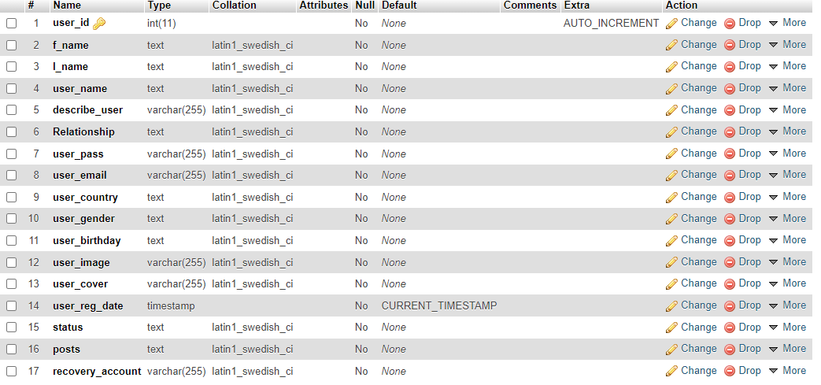**

**Posts**

**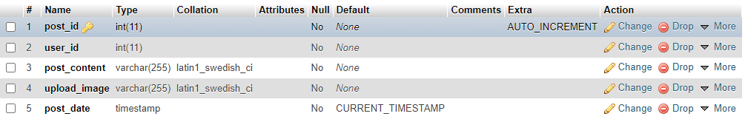**

**Comments**

**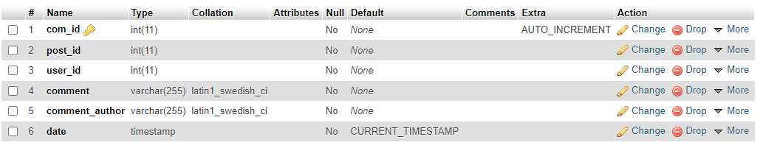**

**ER-DIAGRAM**

users

writes

comments

posts

**VALIDATION CHECK**

We have incorporated following checks for validation of user input

1. All primary key fields must not be NULL.

2. All character type fields never accept blank space.

3. Numeric fields must not accept nonnumeric value.

4. Value of fields must not overflow their size.

5. Numeric value must be occurs within their range.

6. In cost benefit report functional cell must not allow to change their value by user.

7. Cursor movement must follow a specific sequence from top to bottom in all entry form.

**SOURCE CODE AND SCREEN OUTPUT**

**Landing page**

**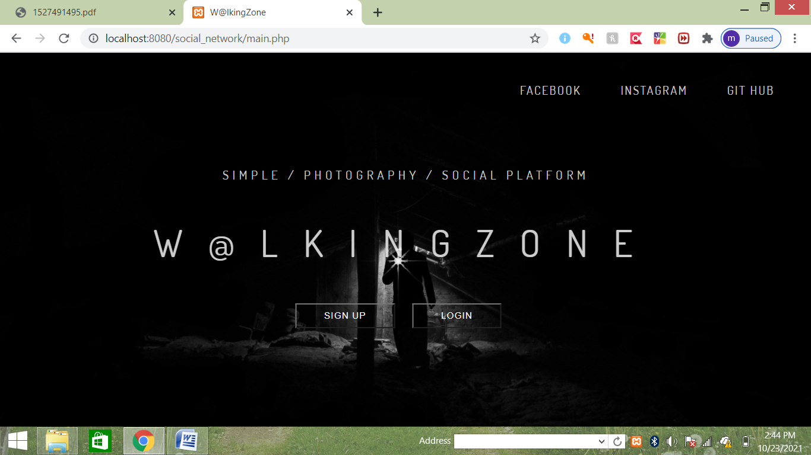**

**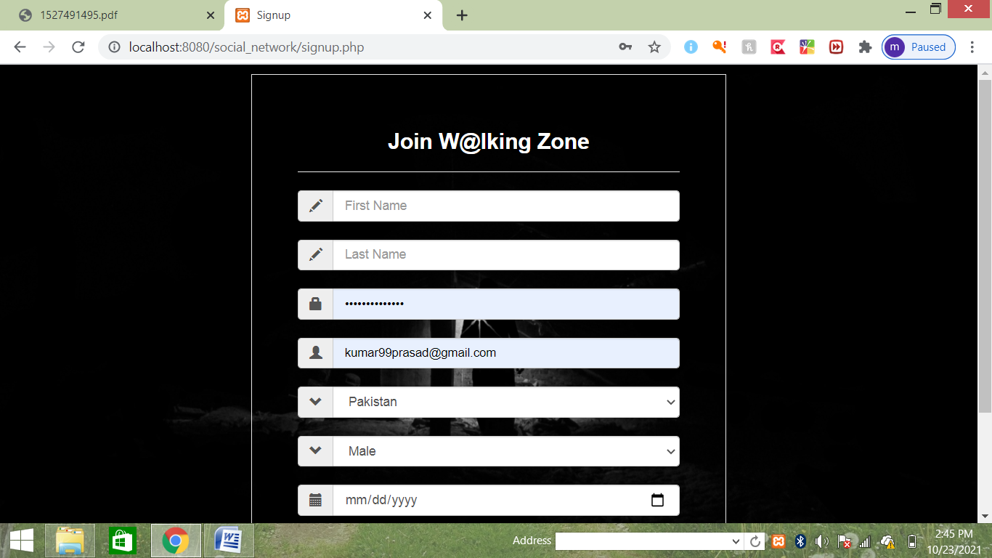**

**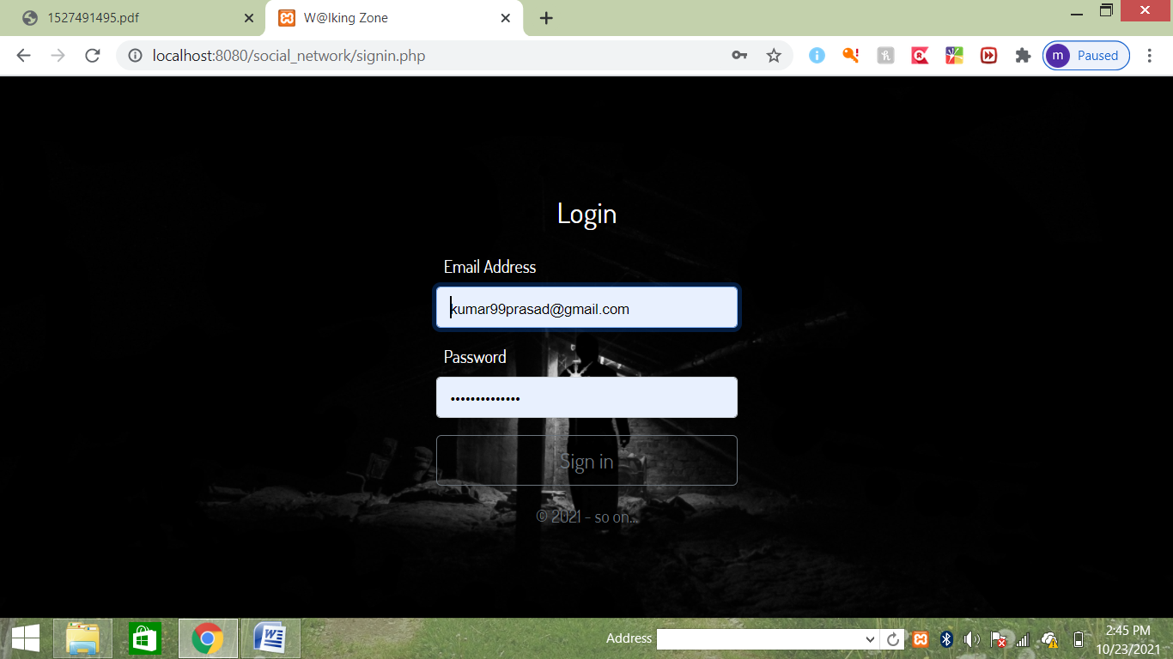**

**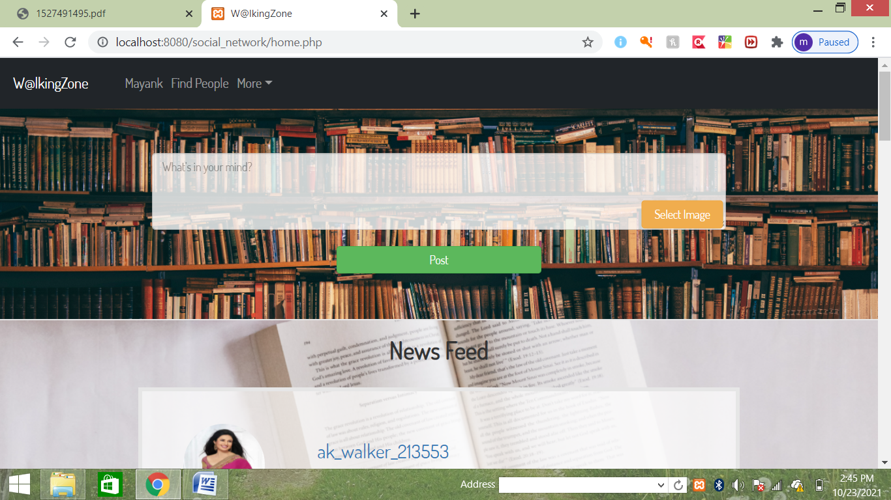**

**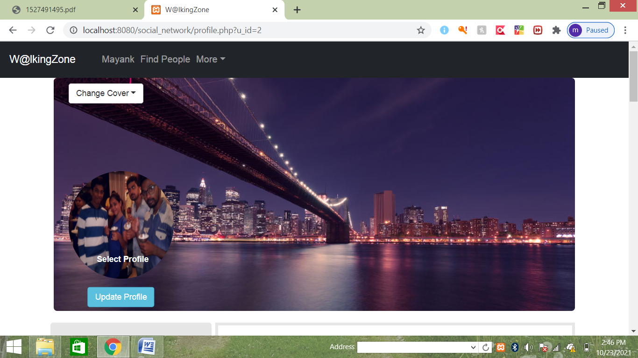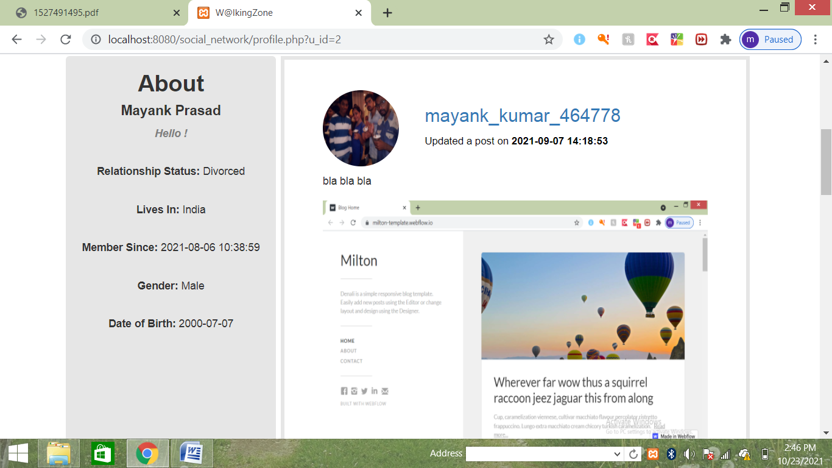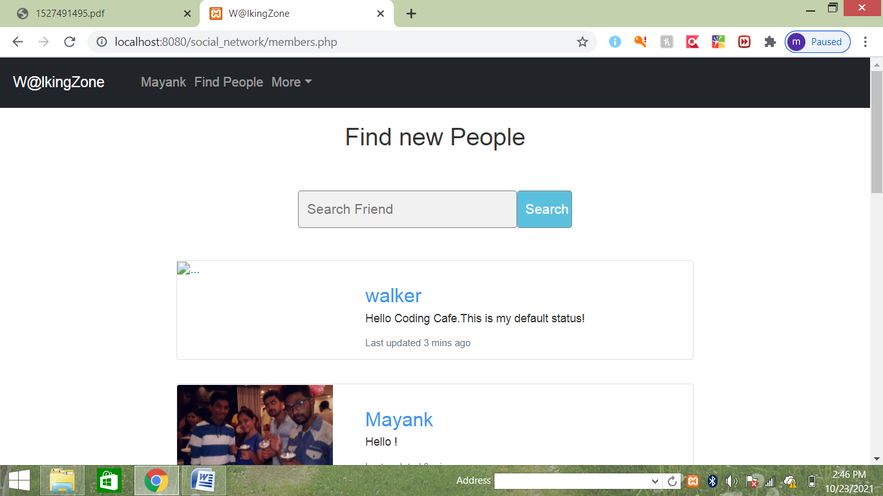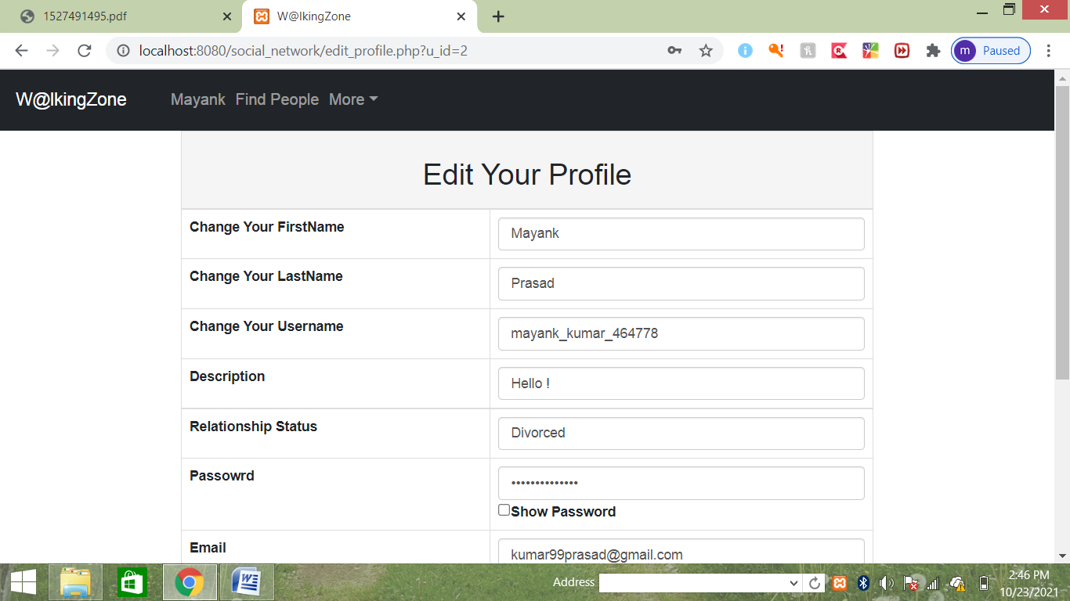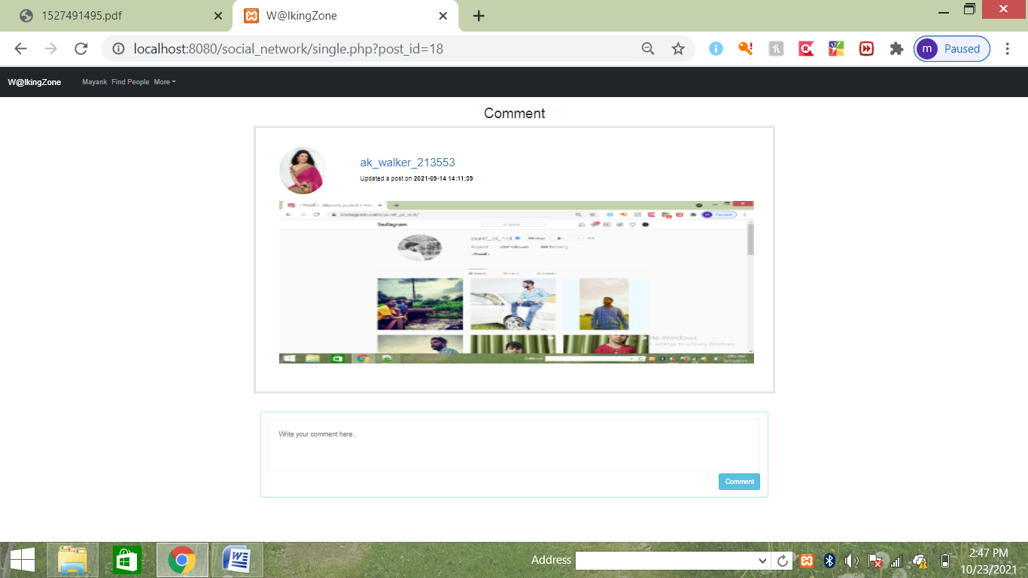**

**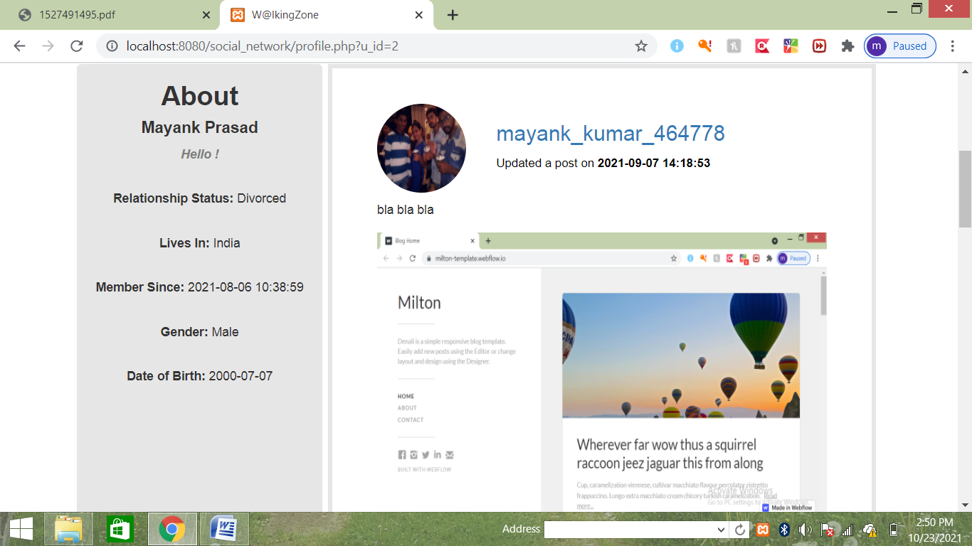**

**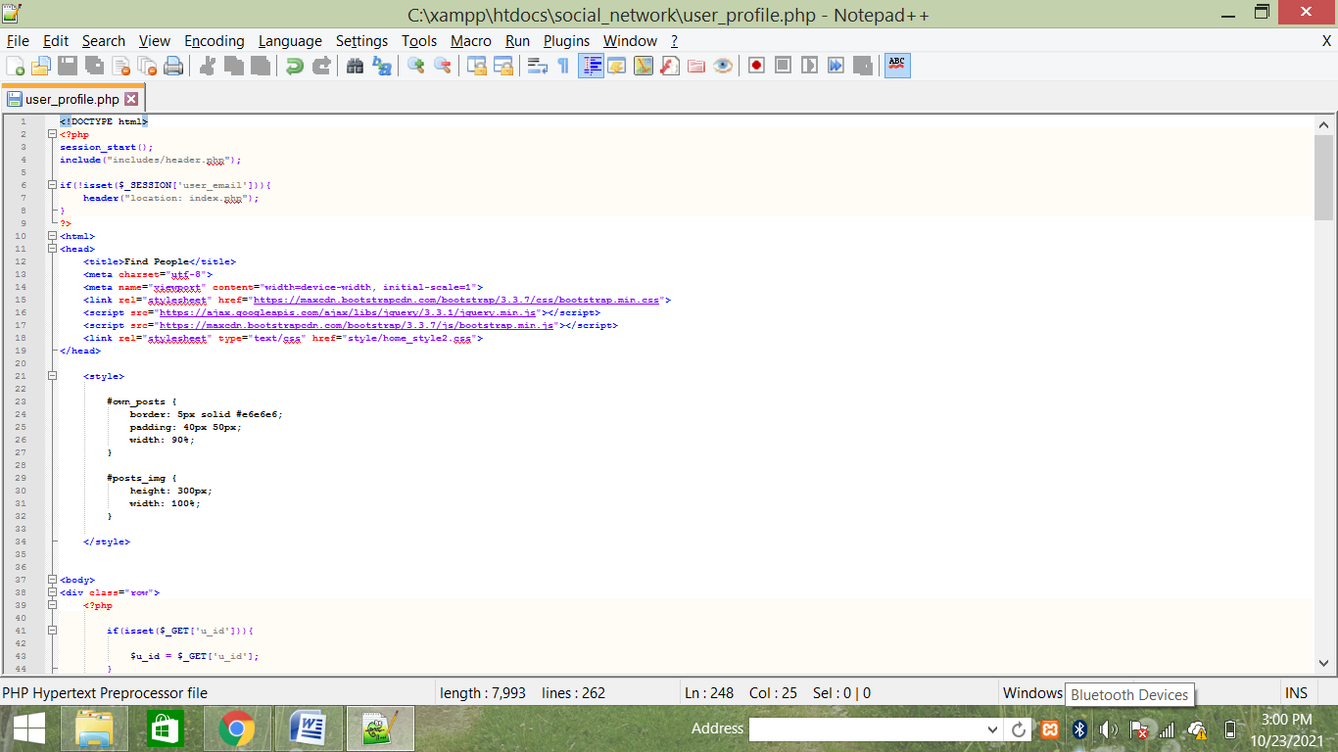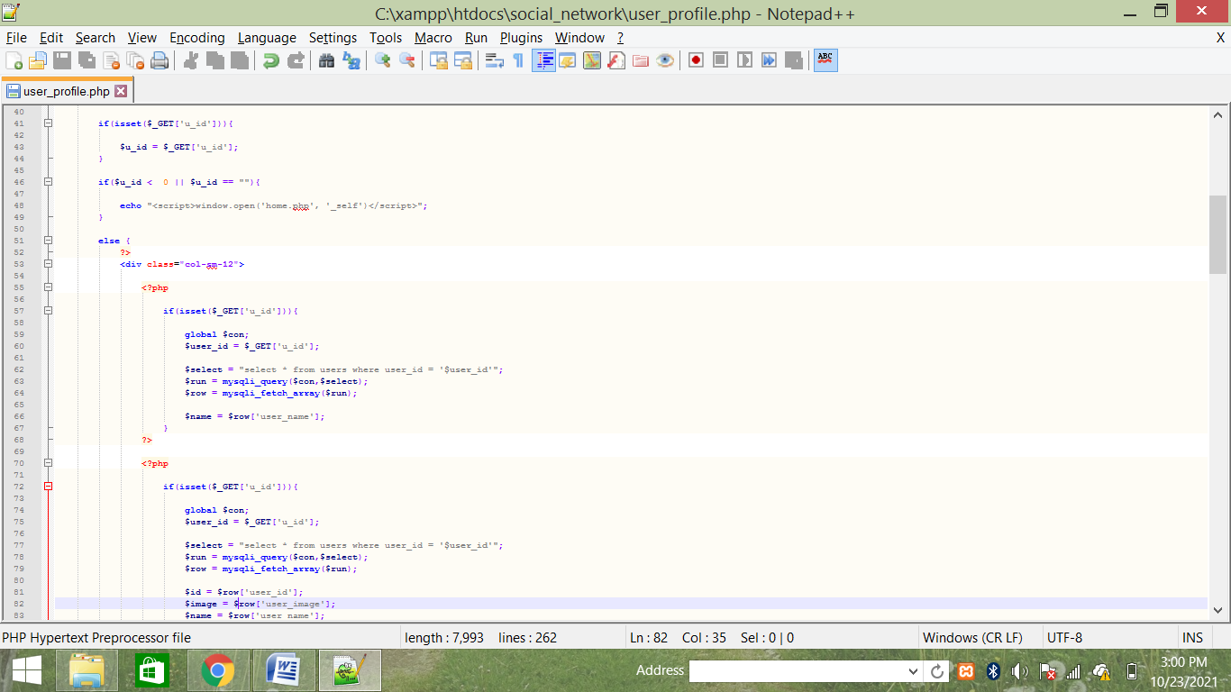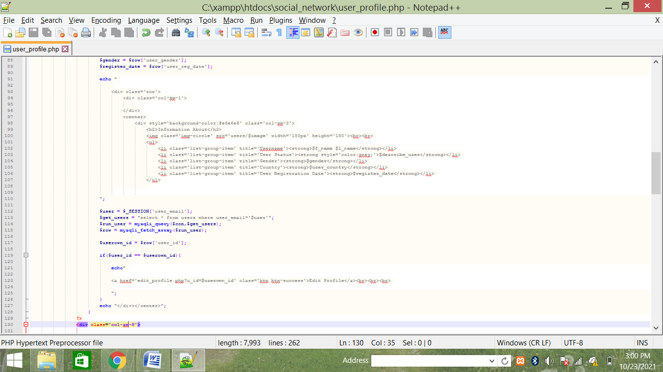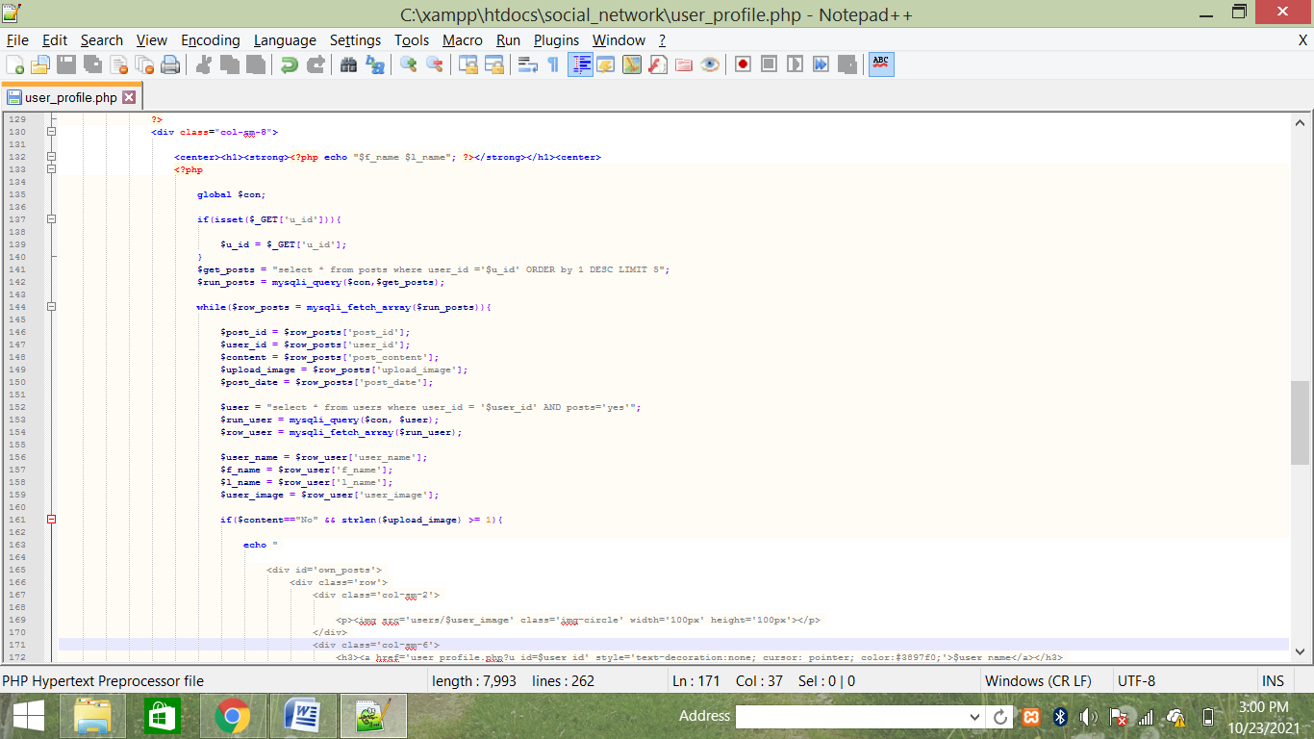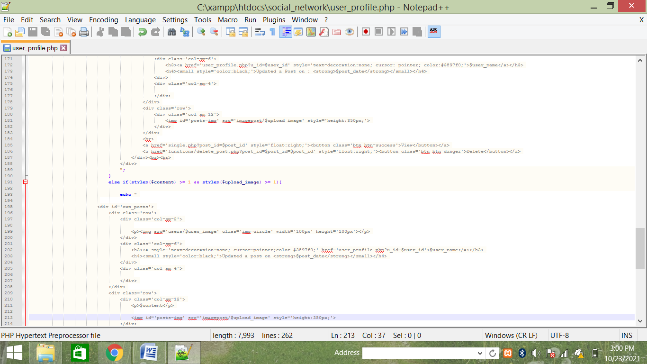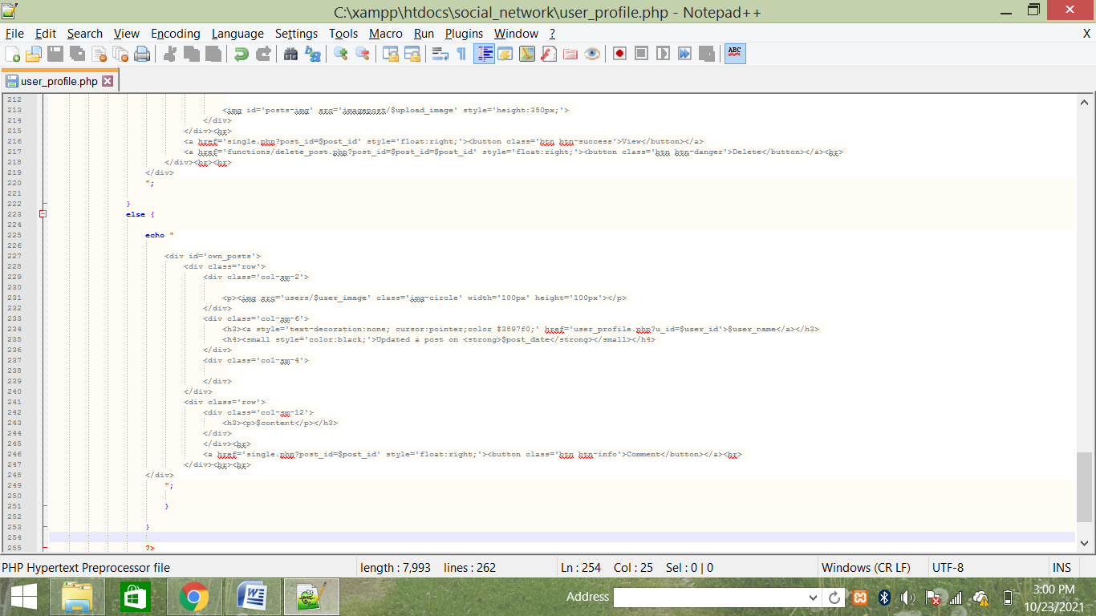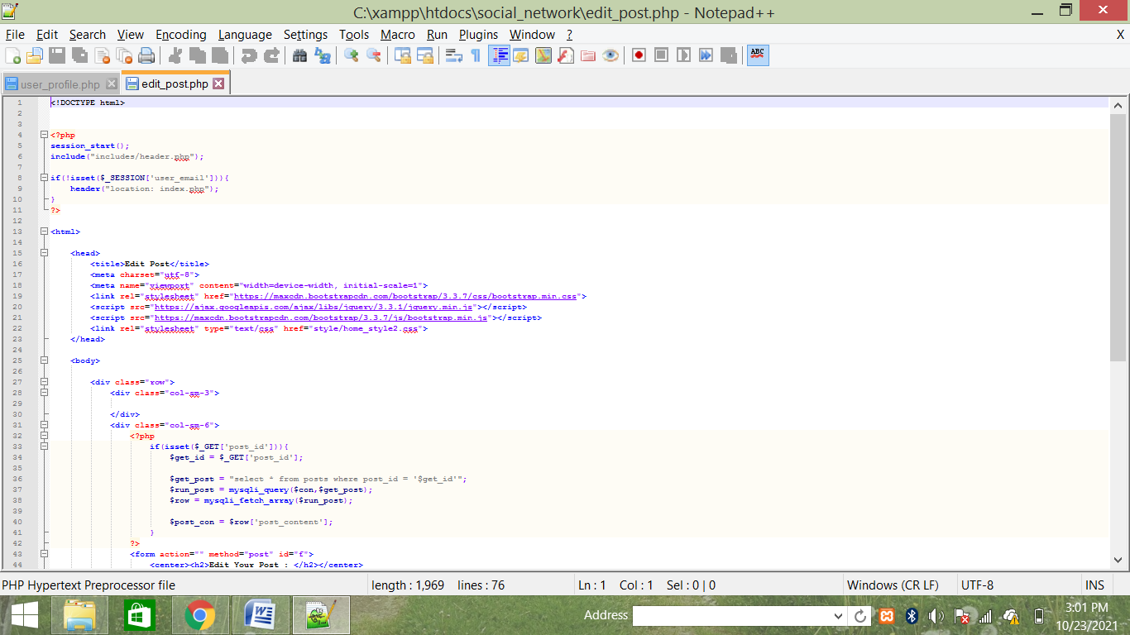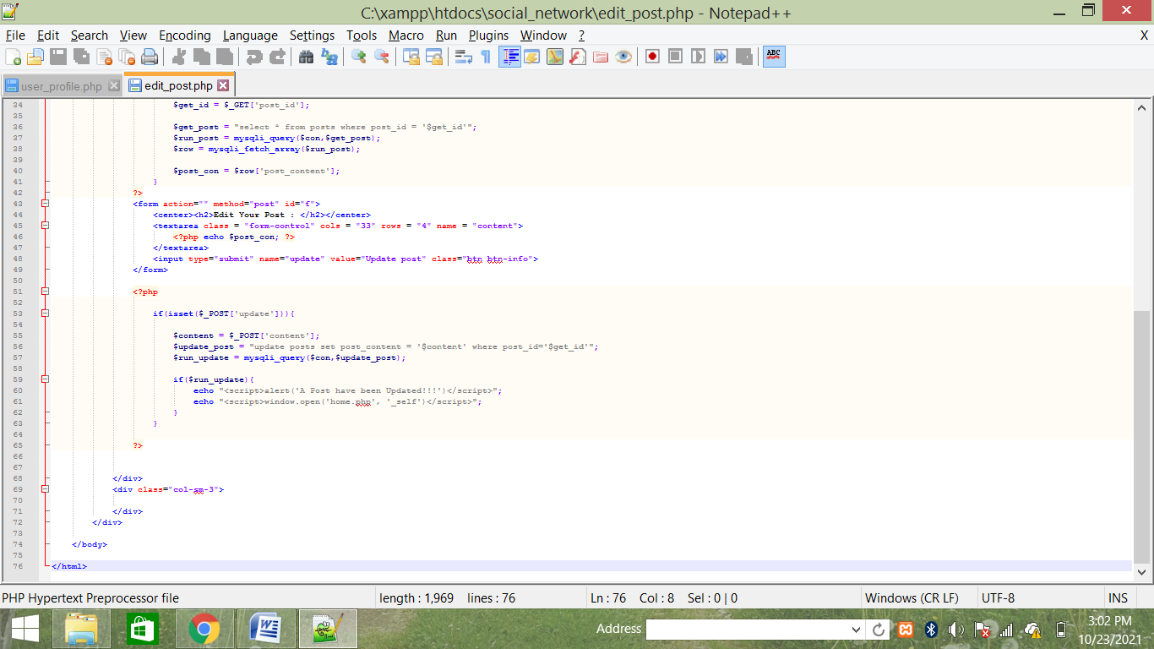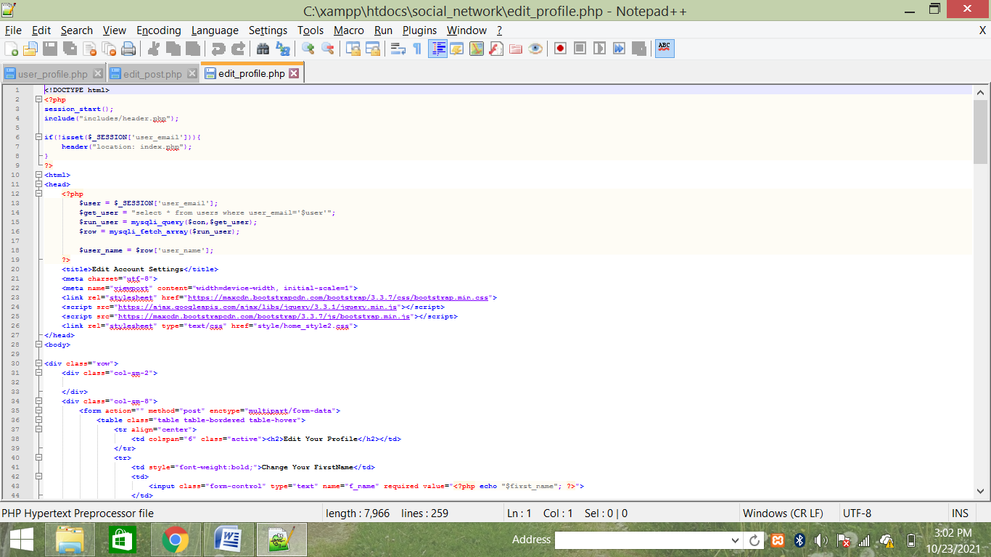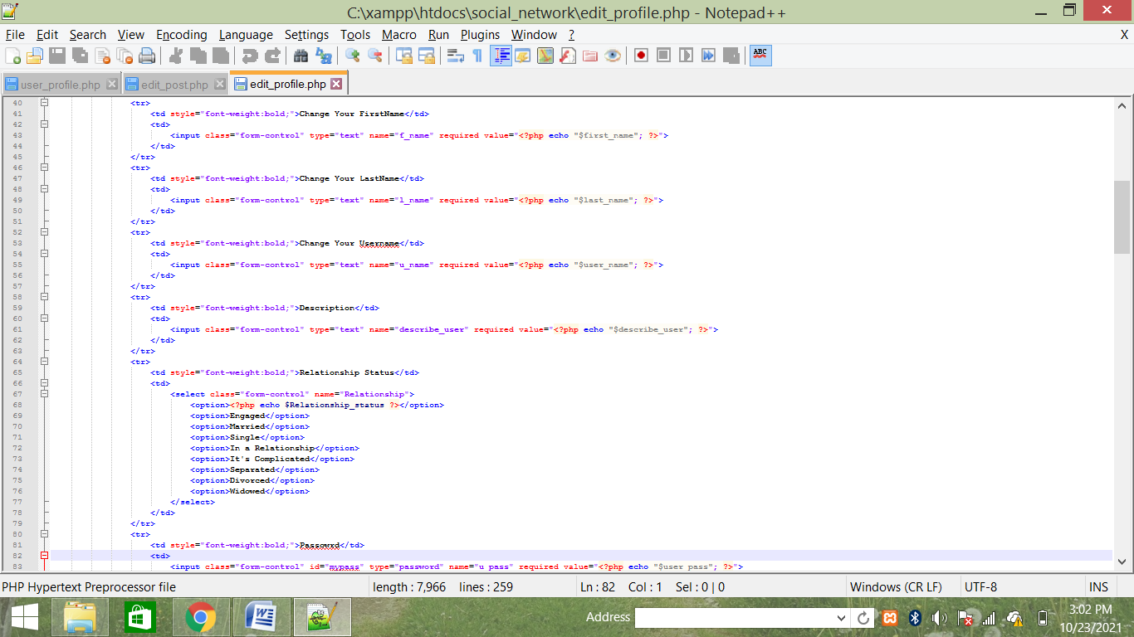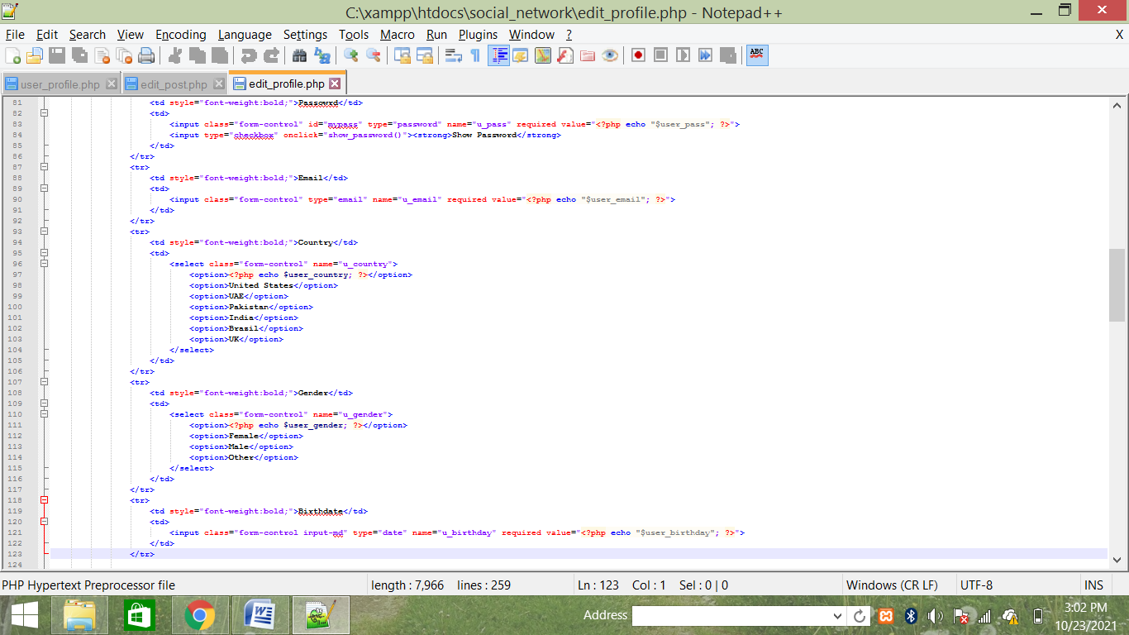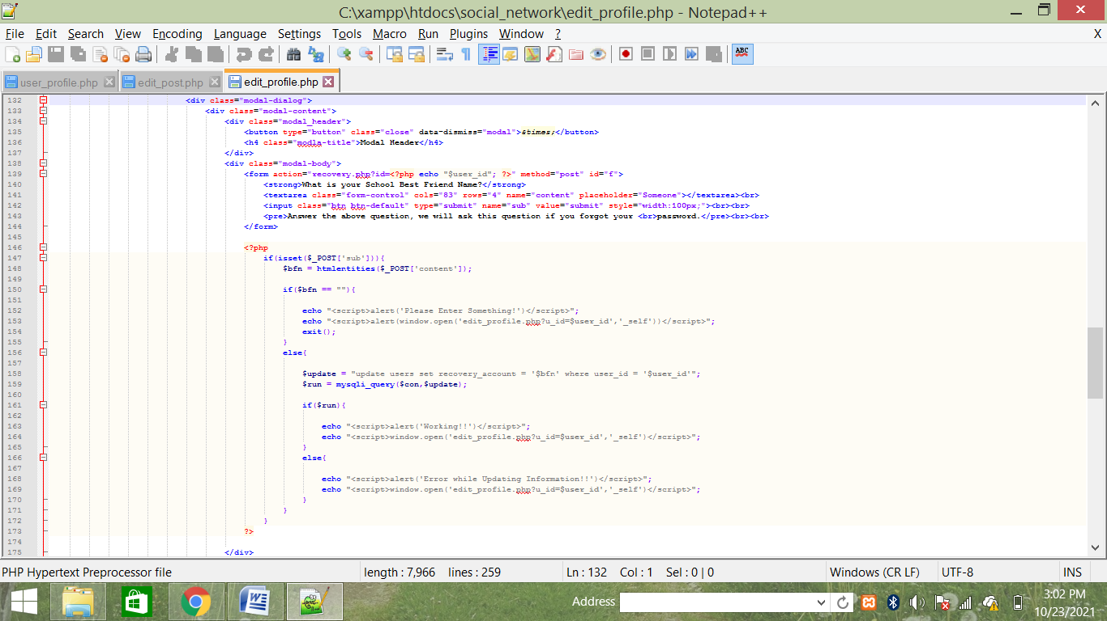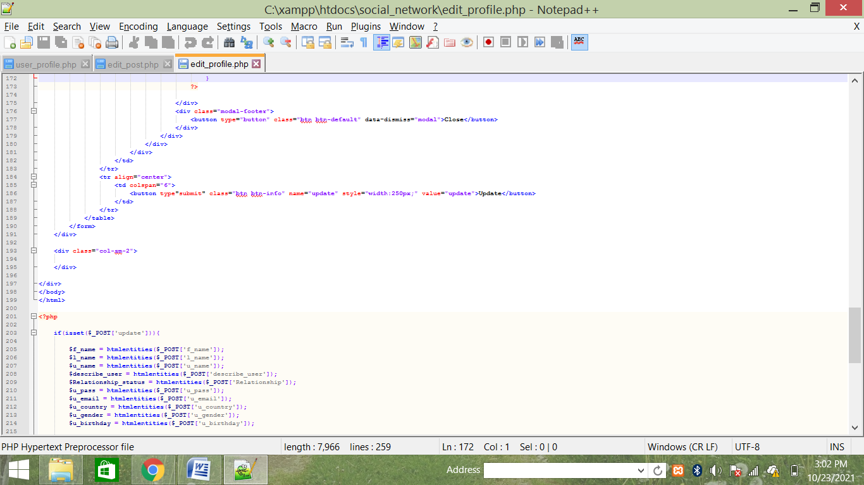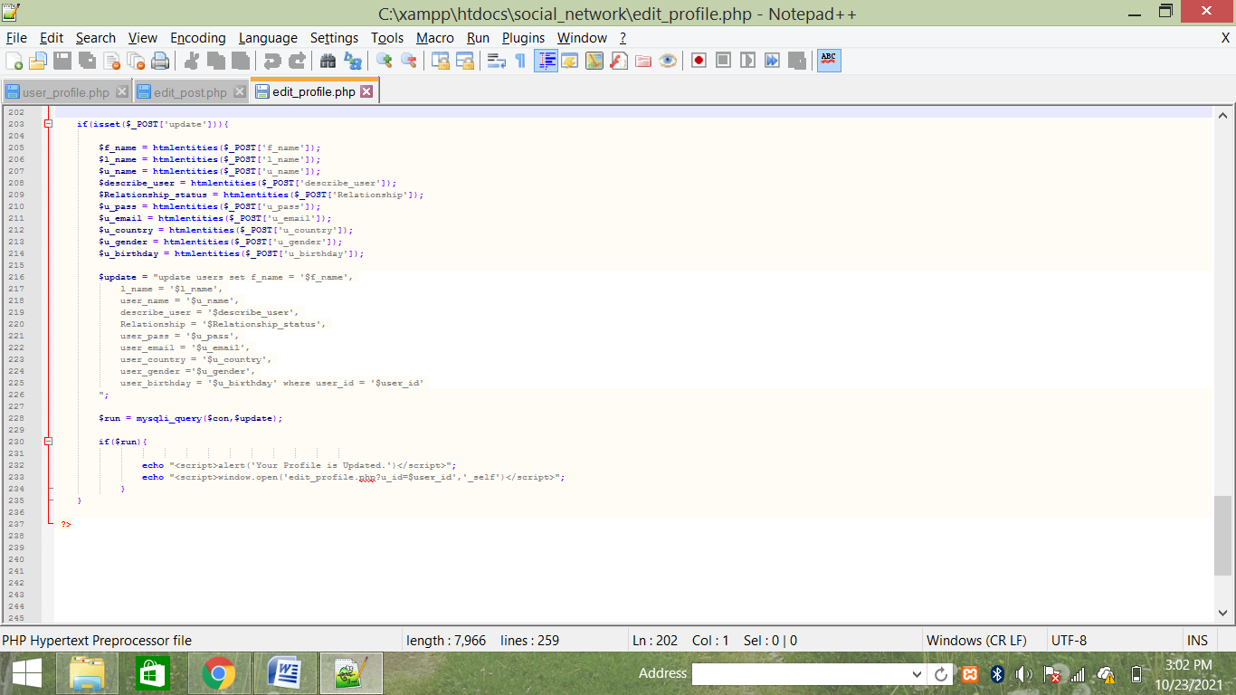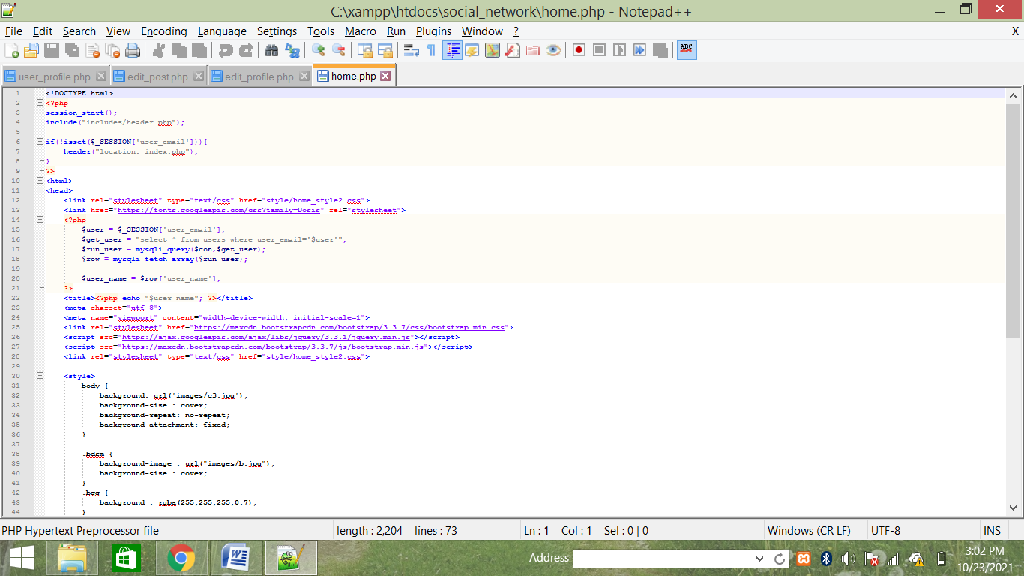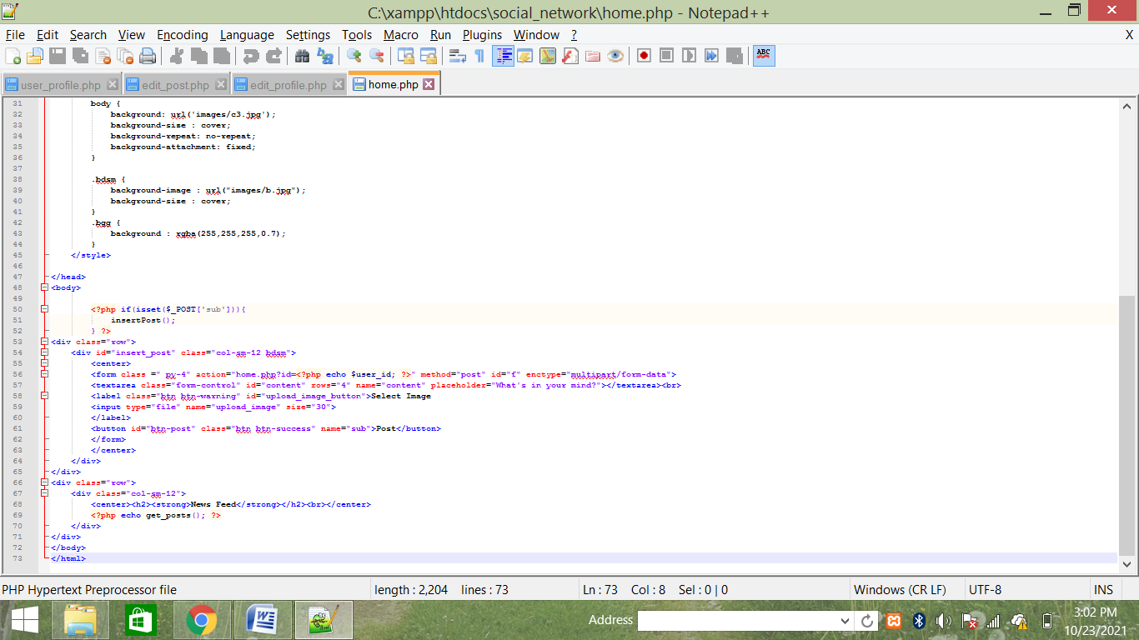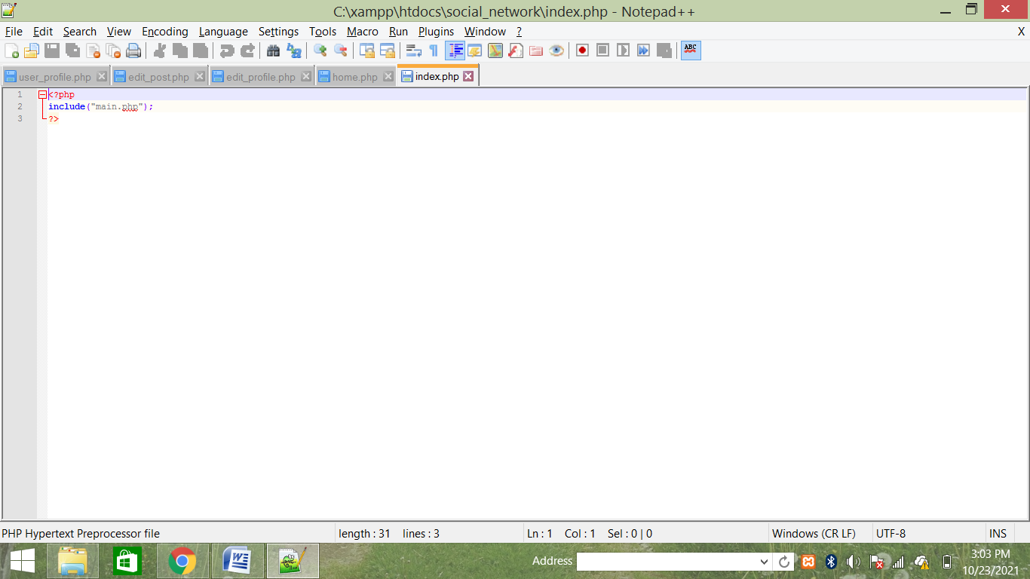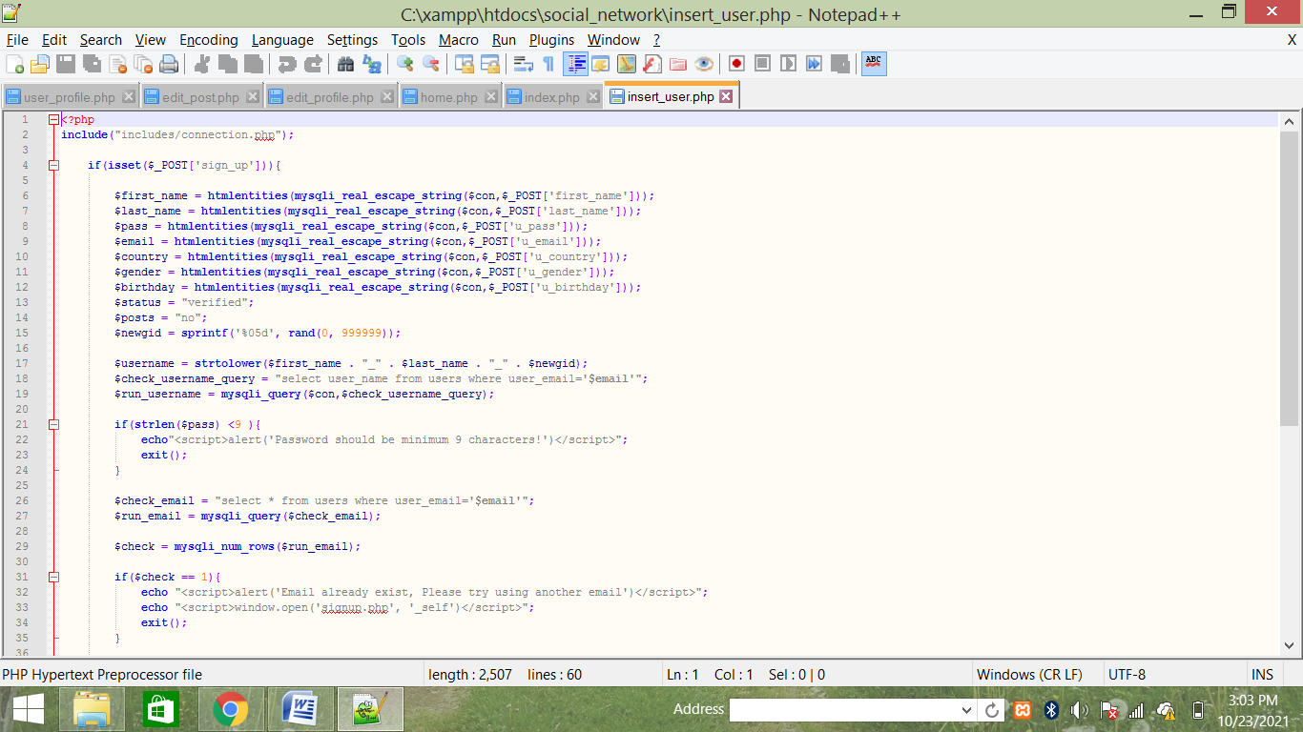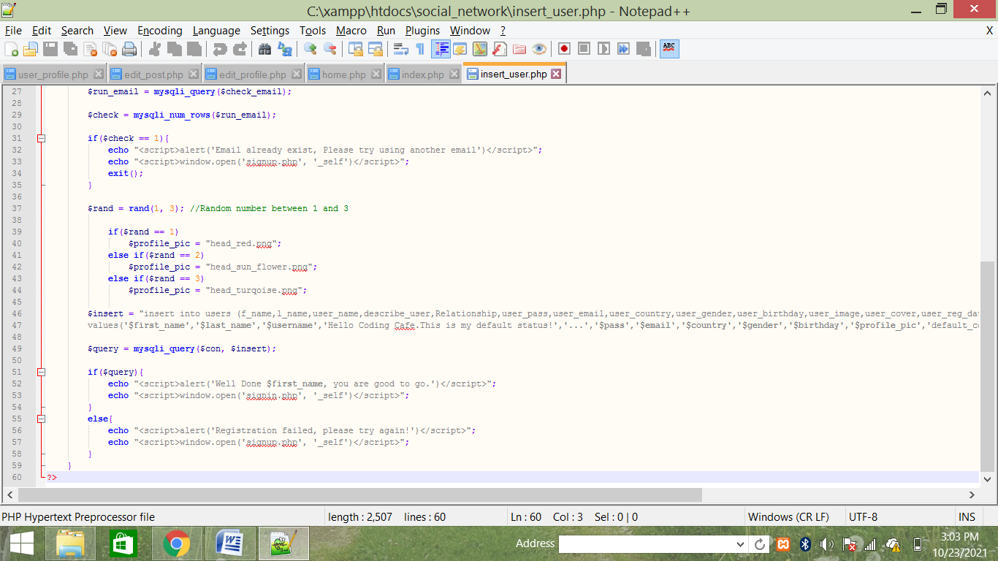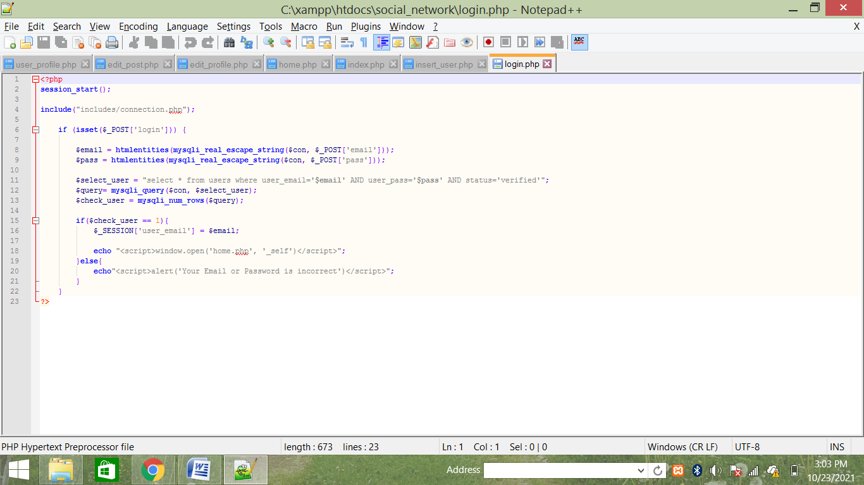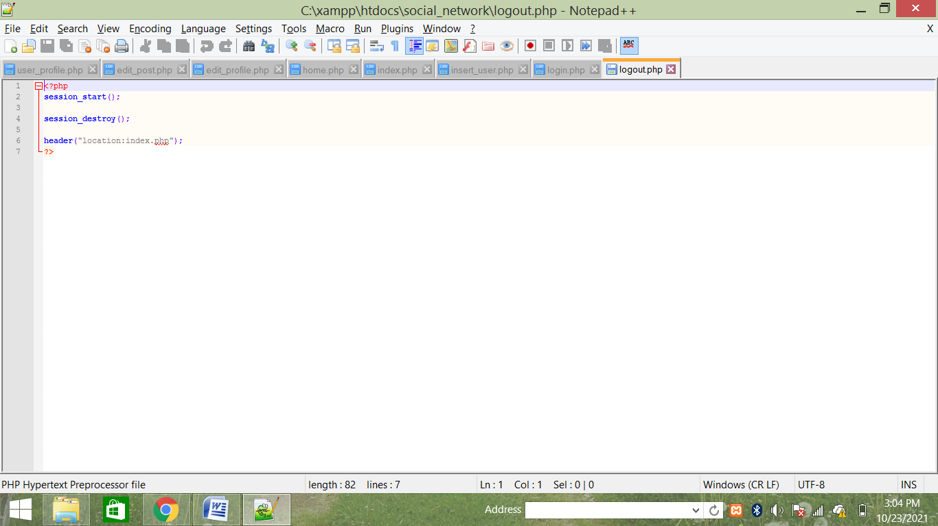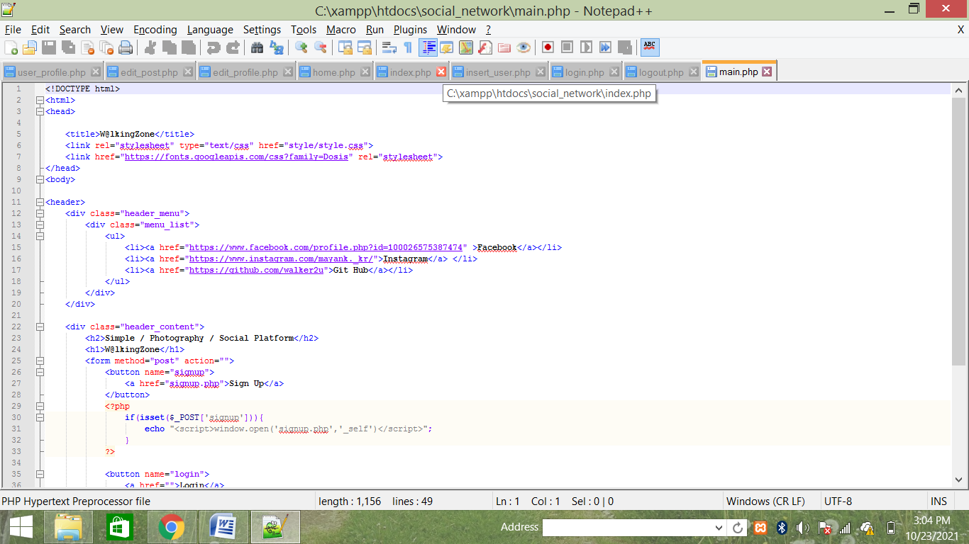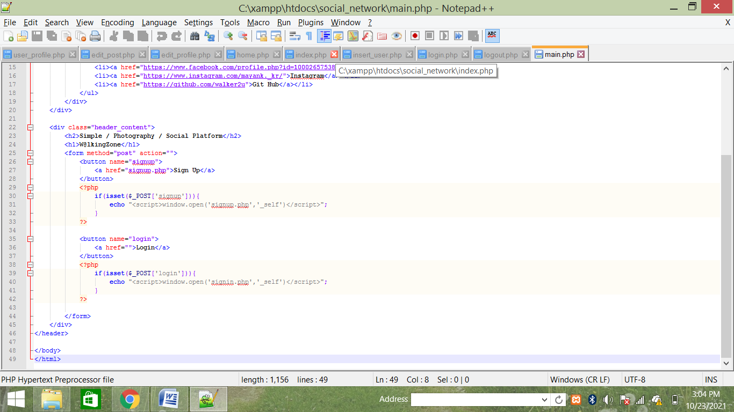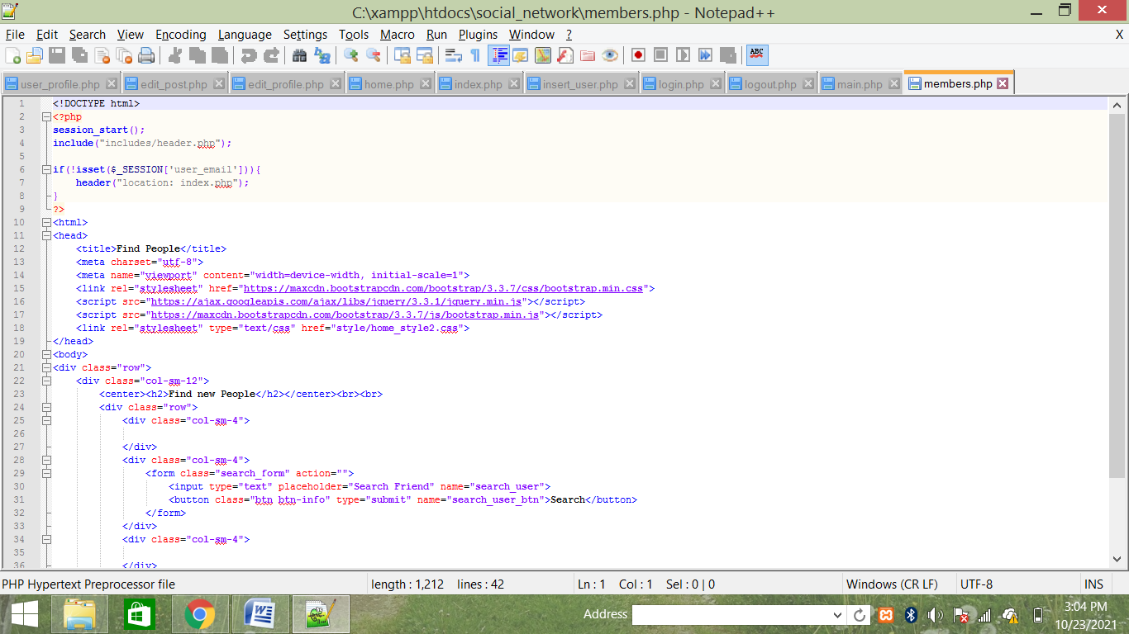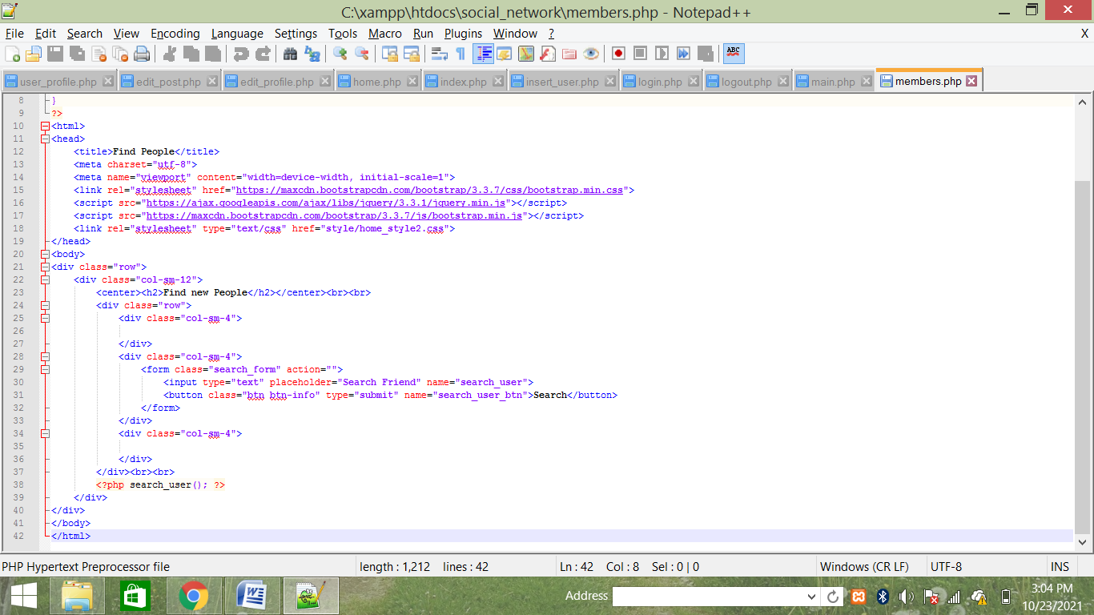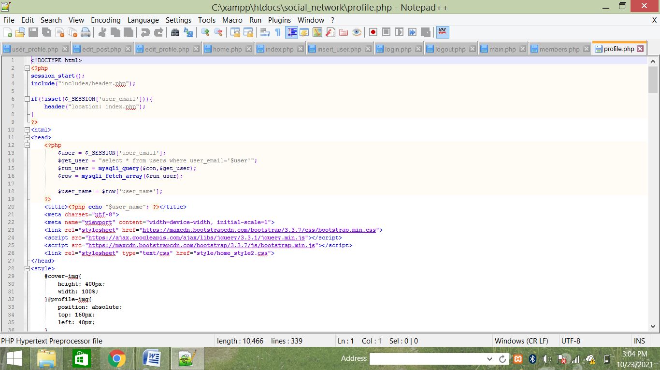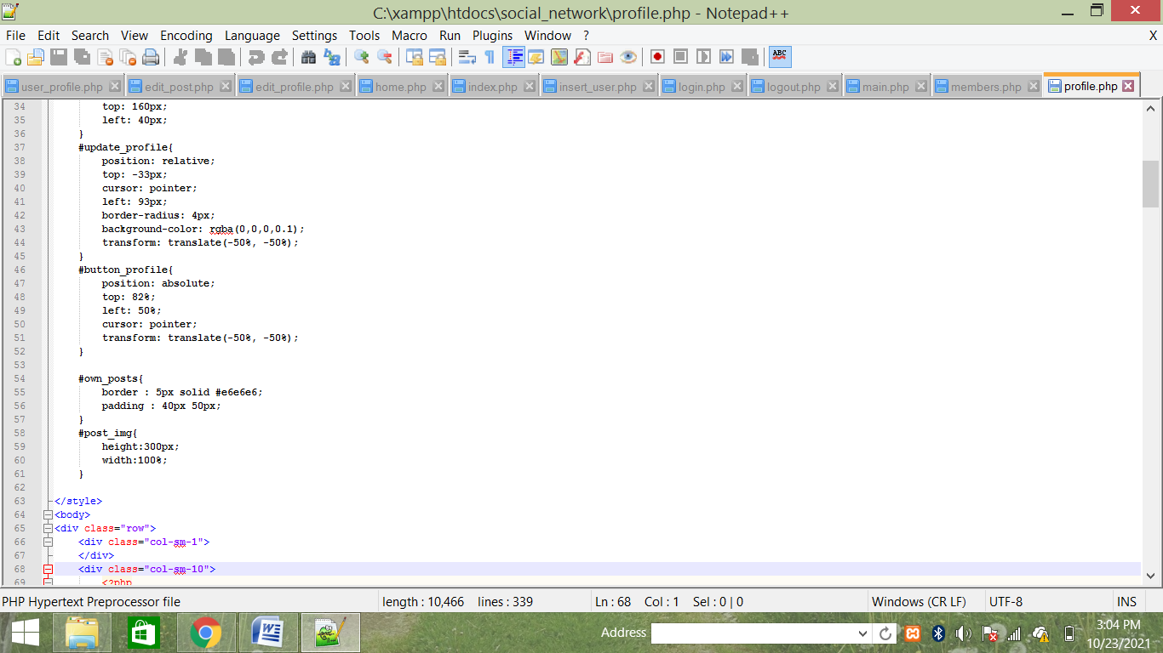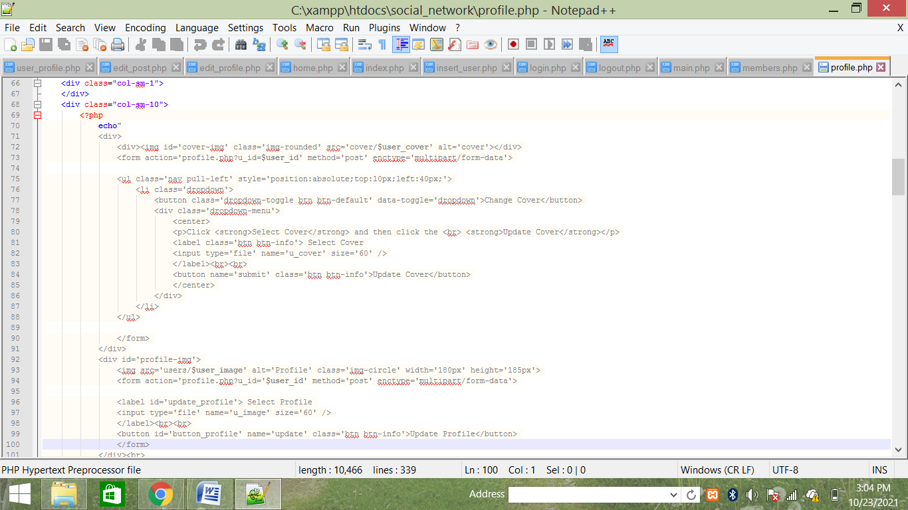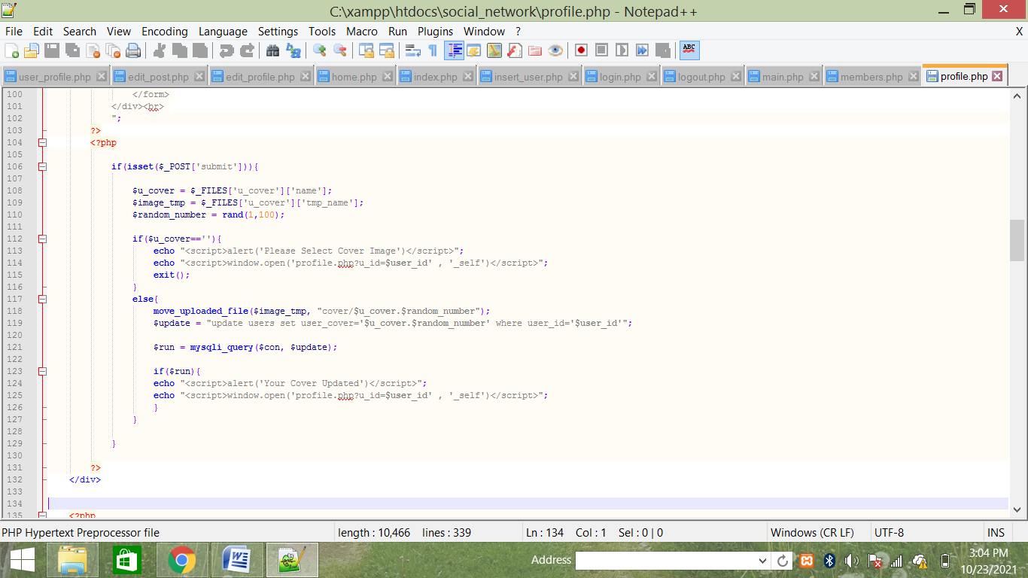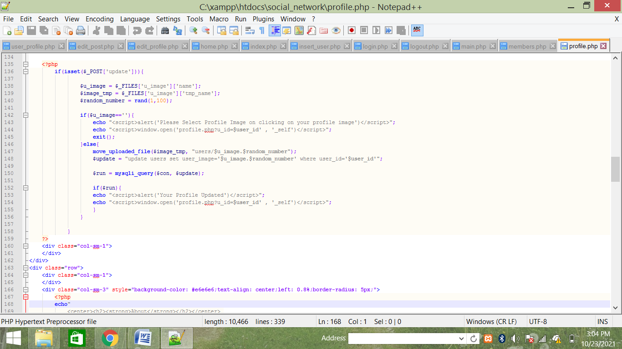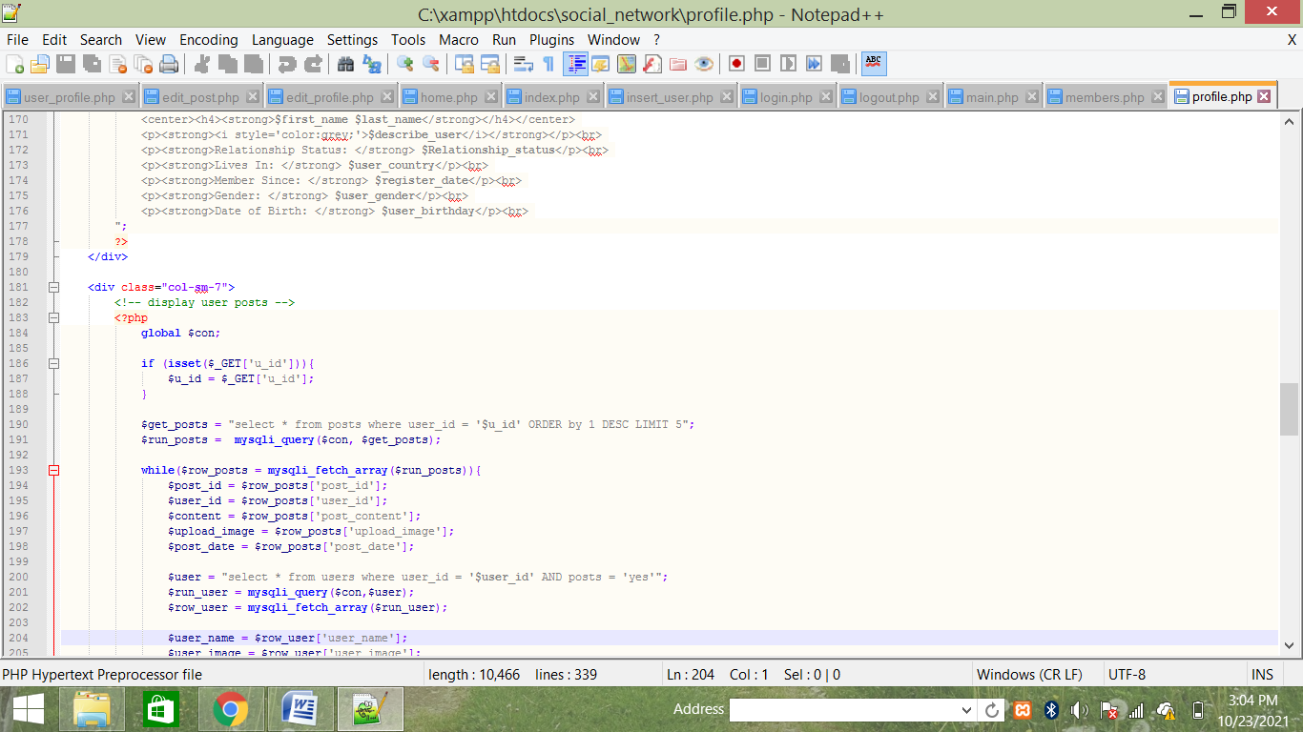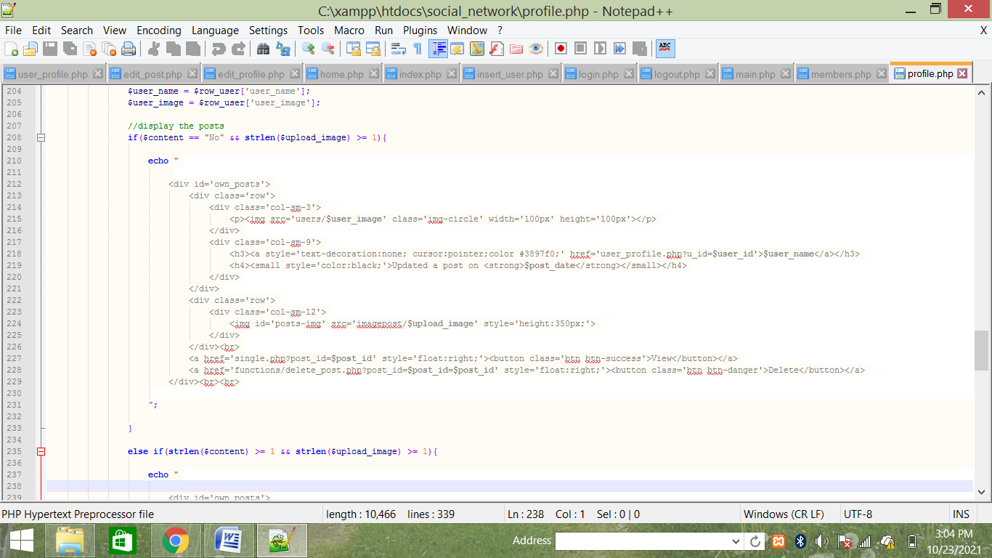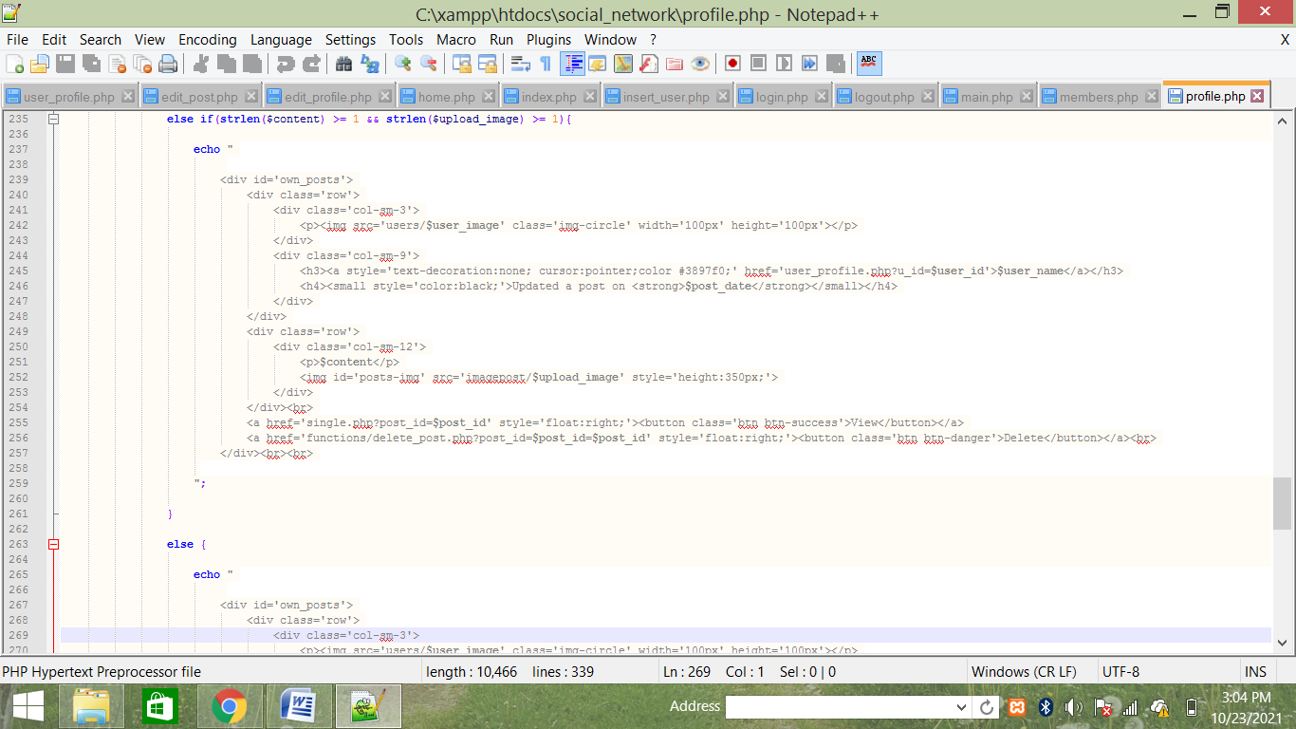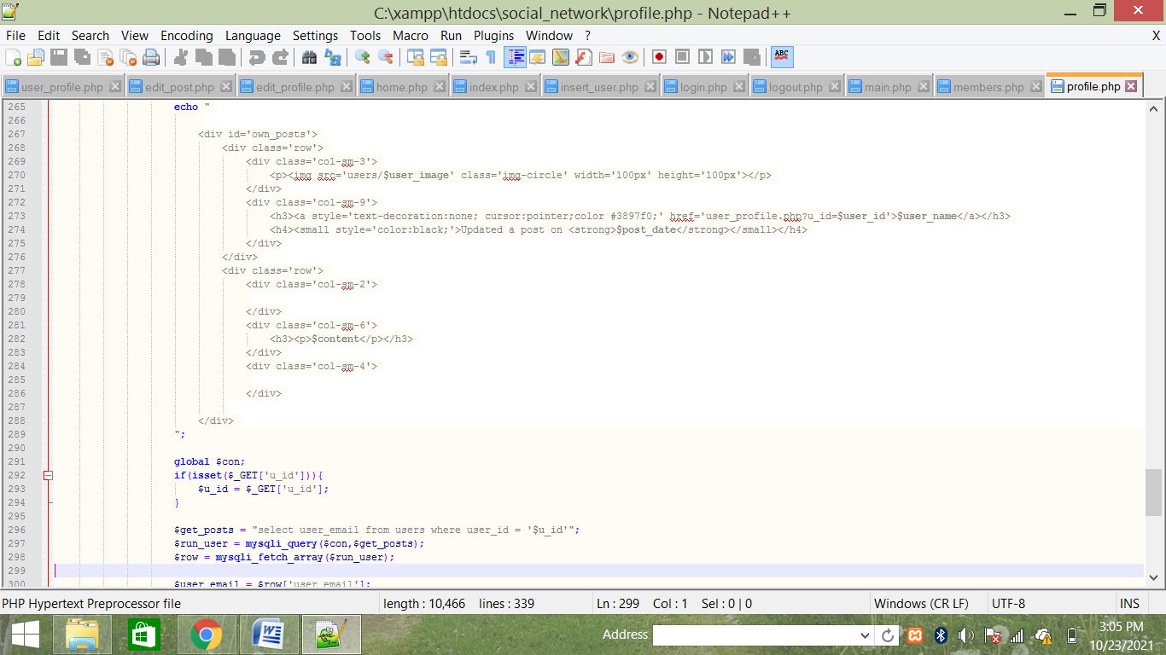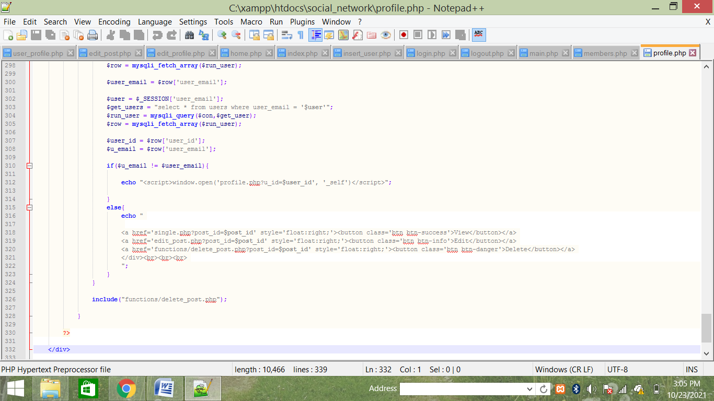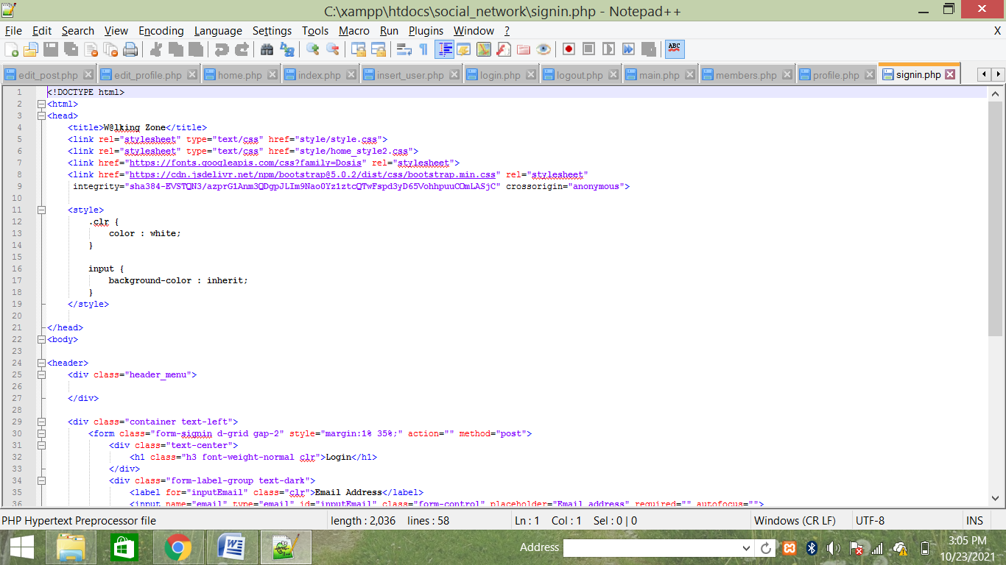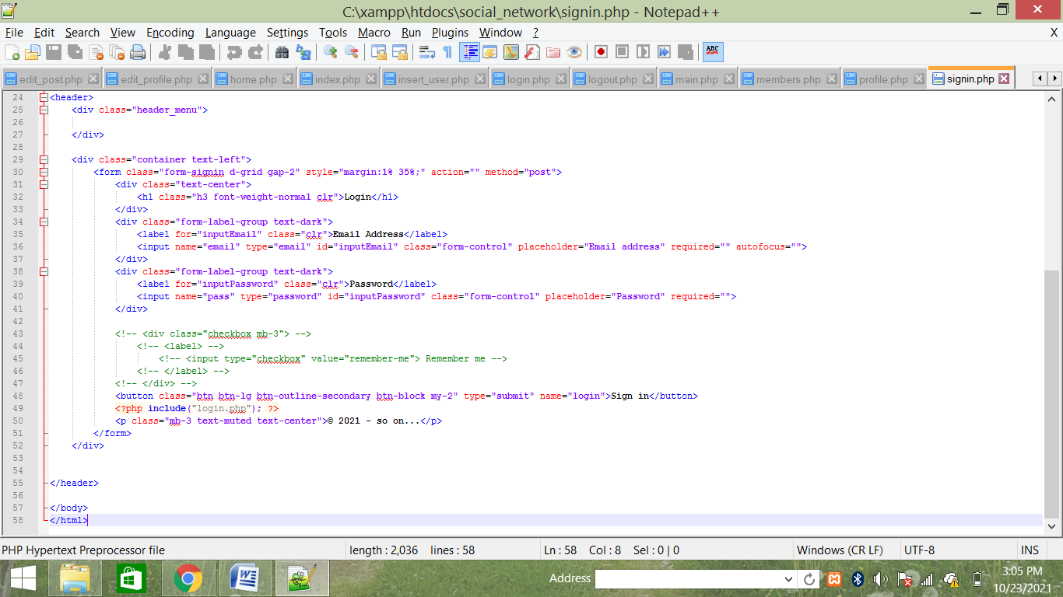**

**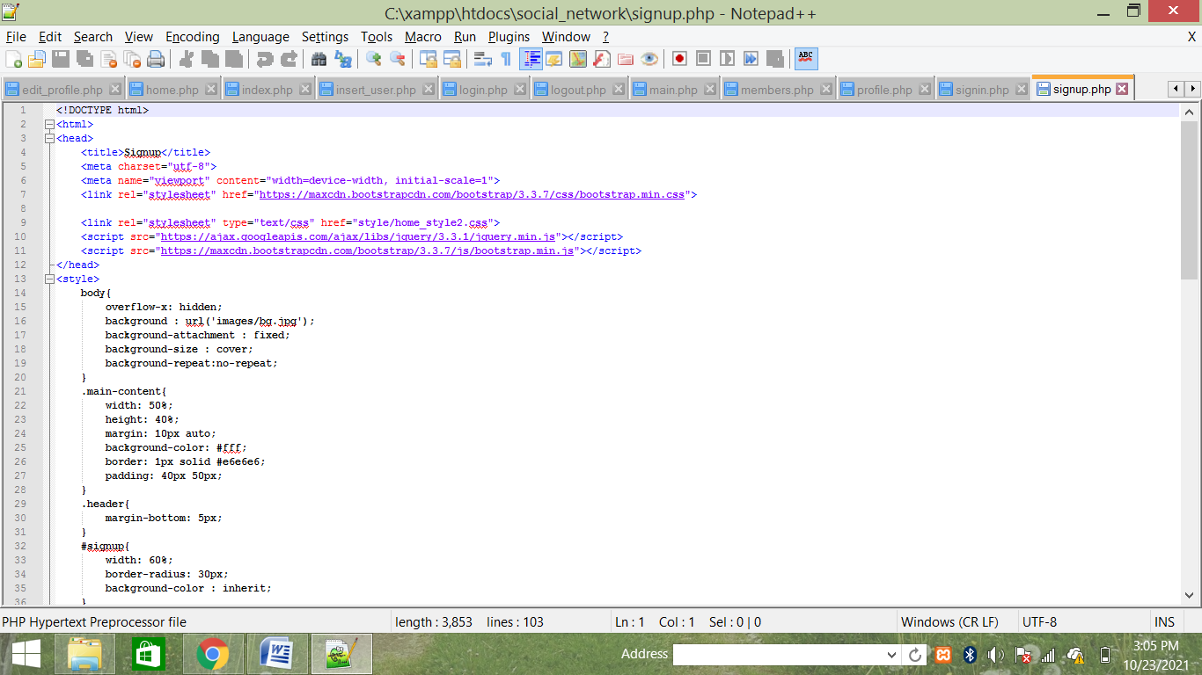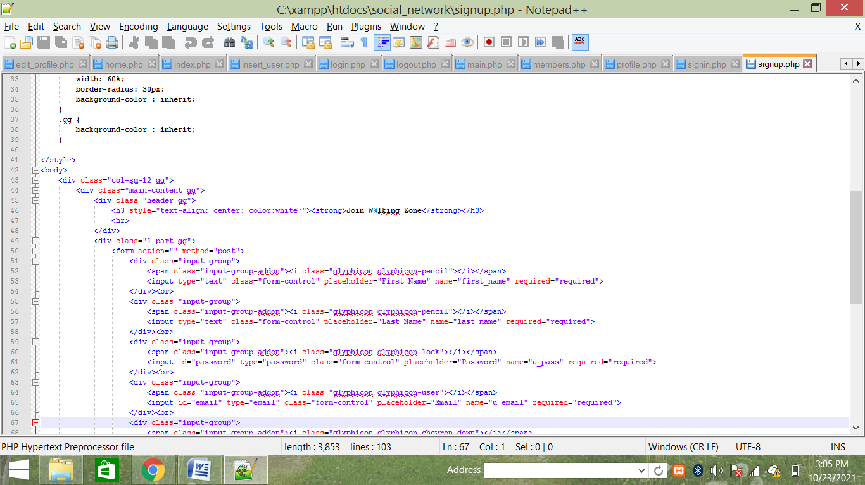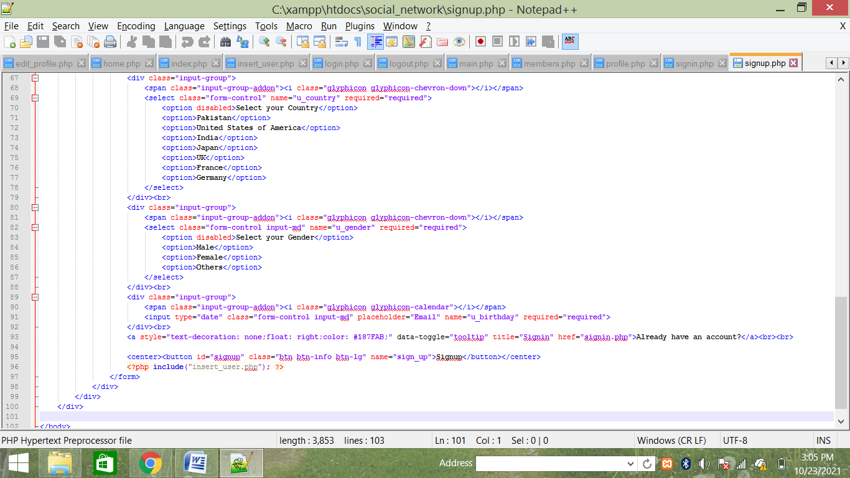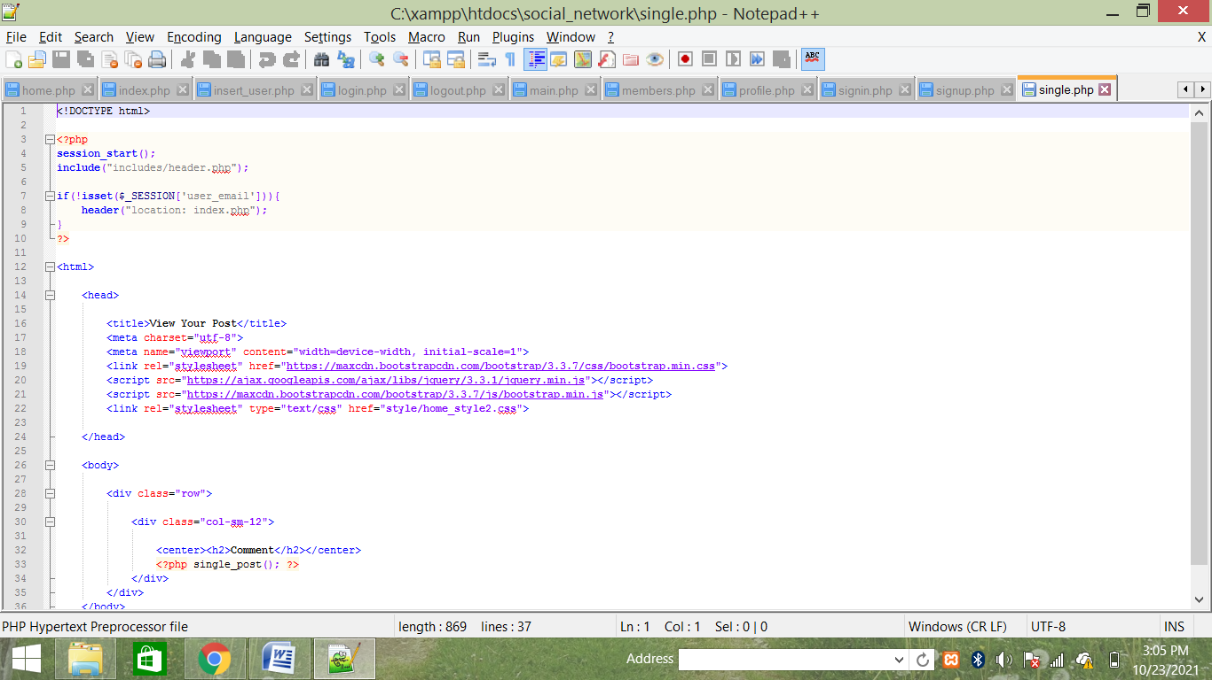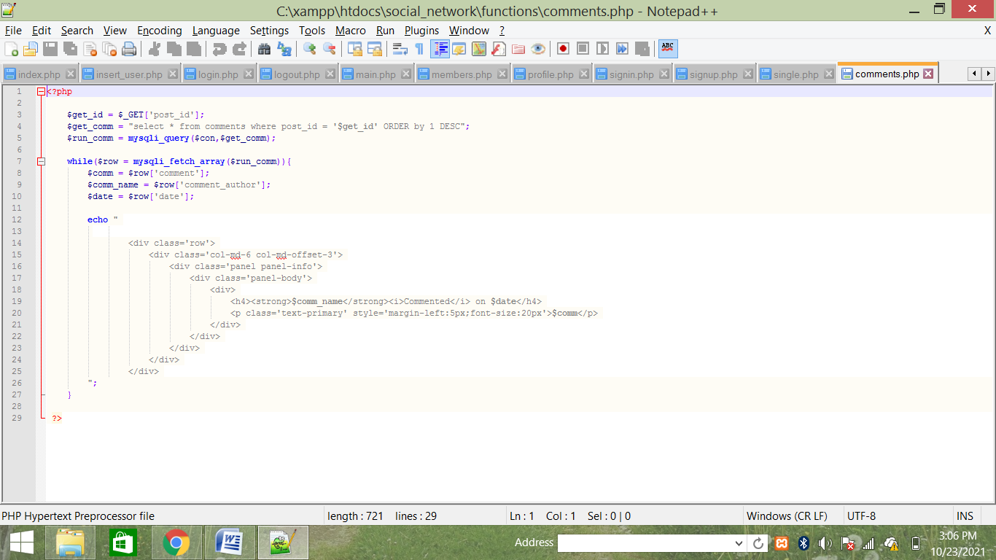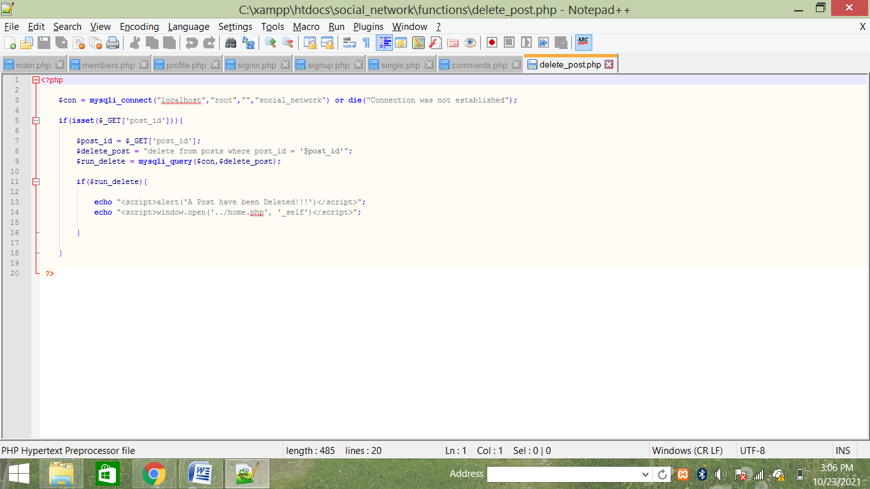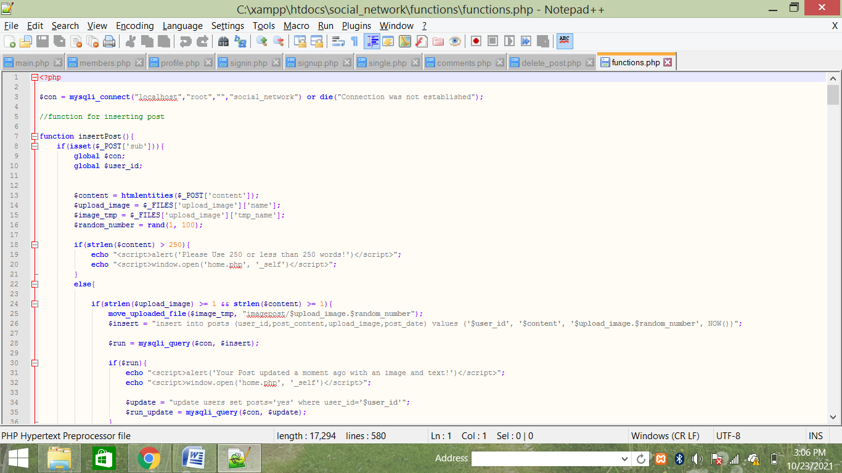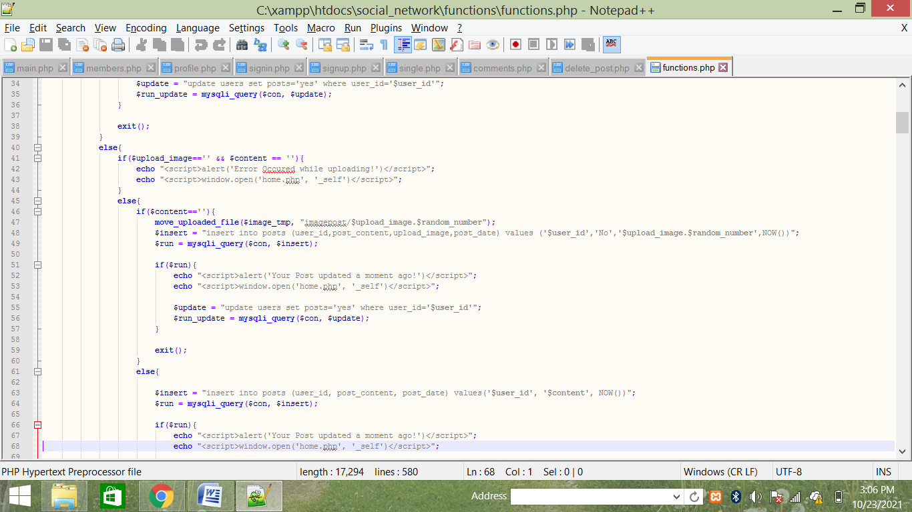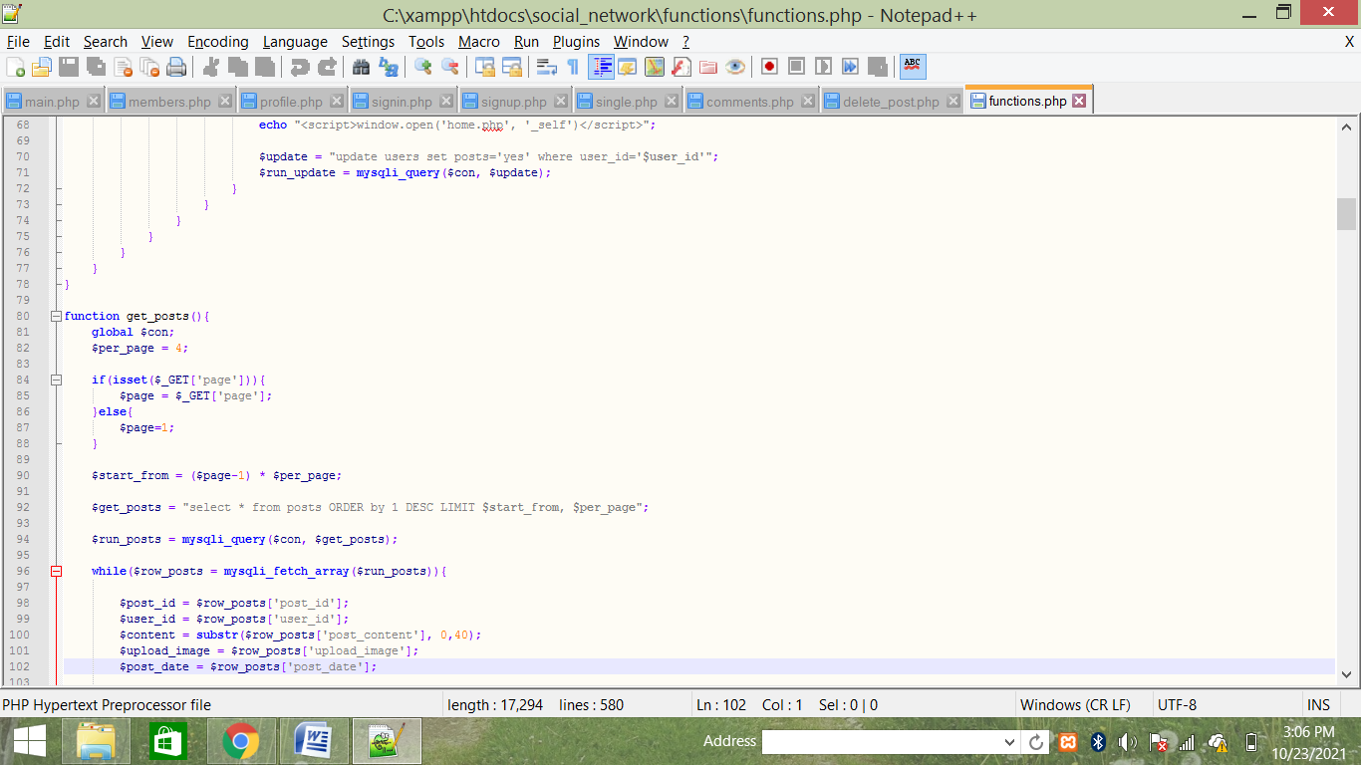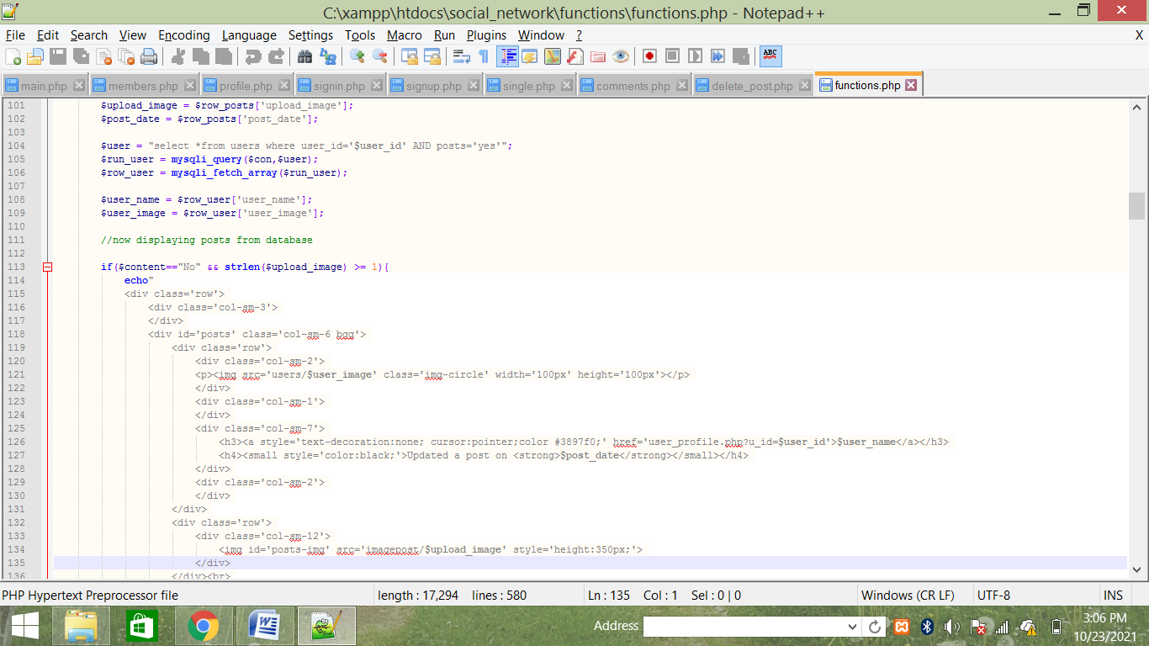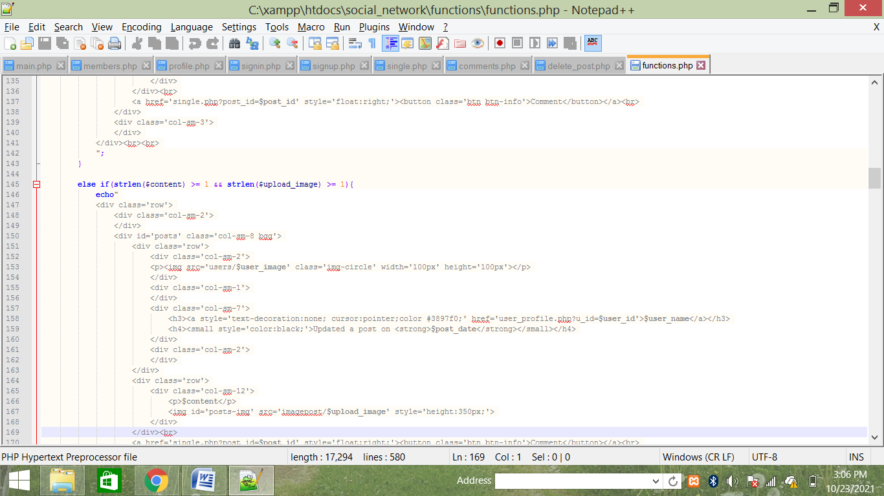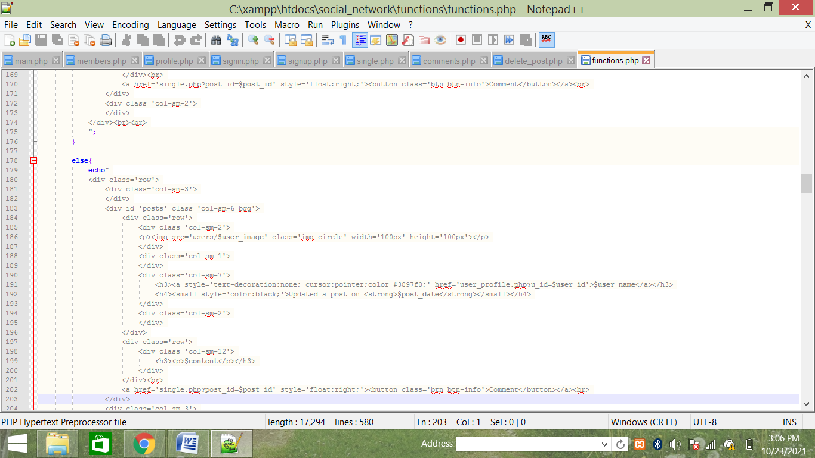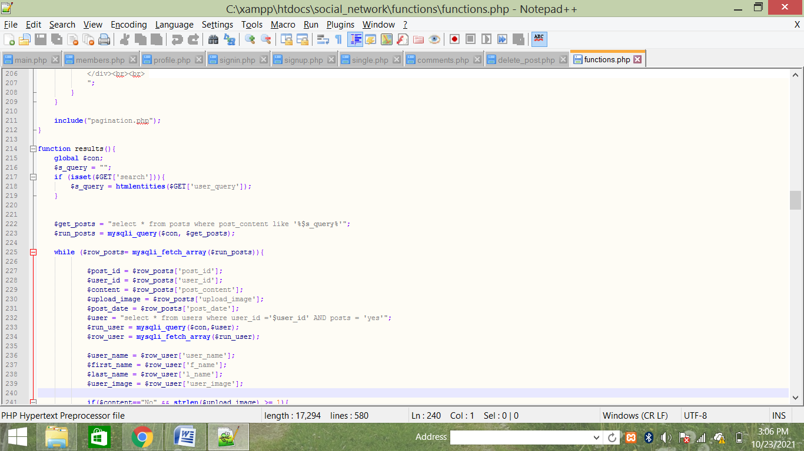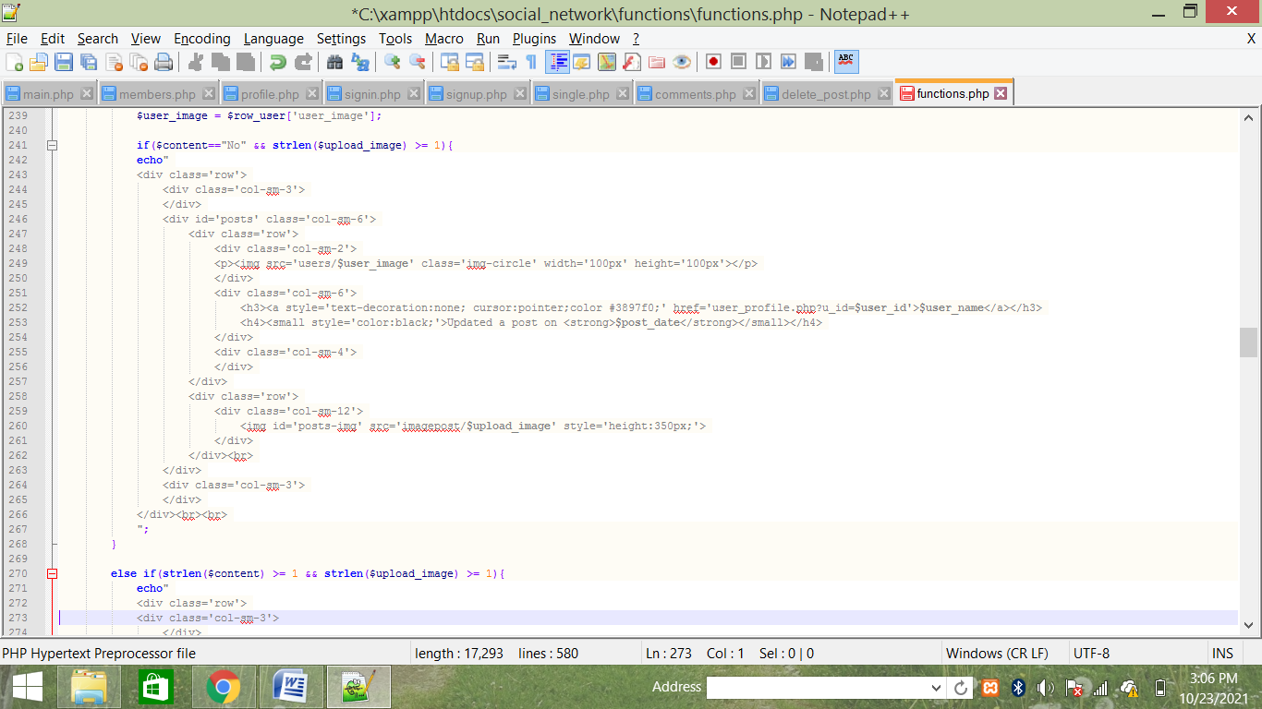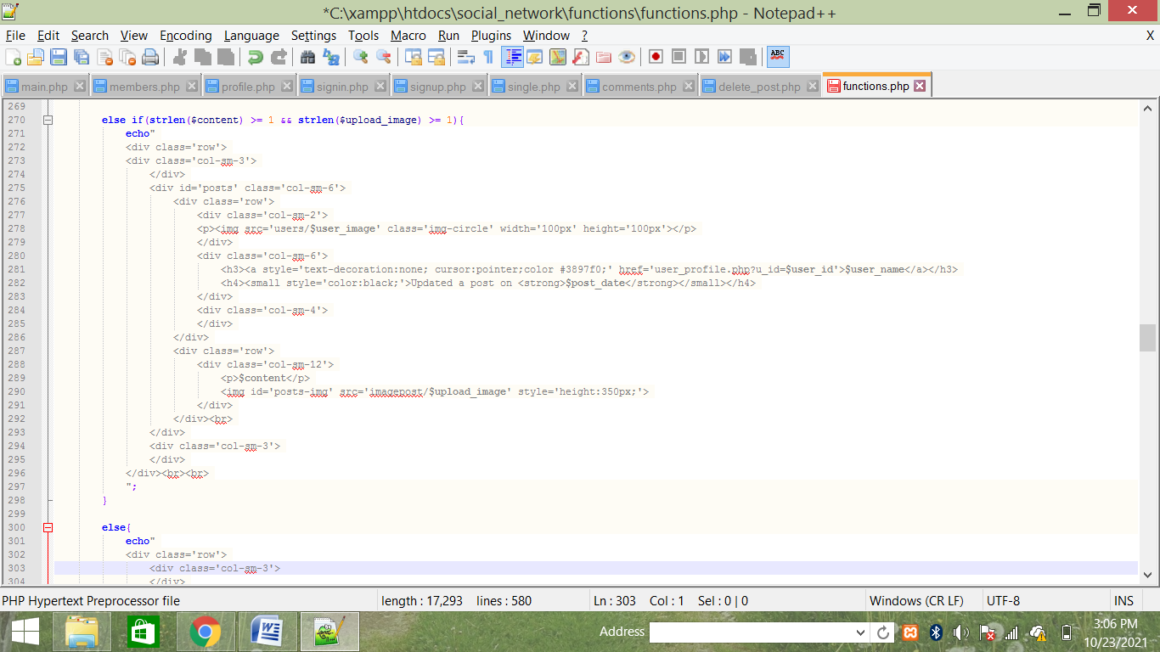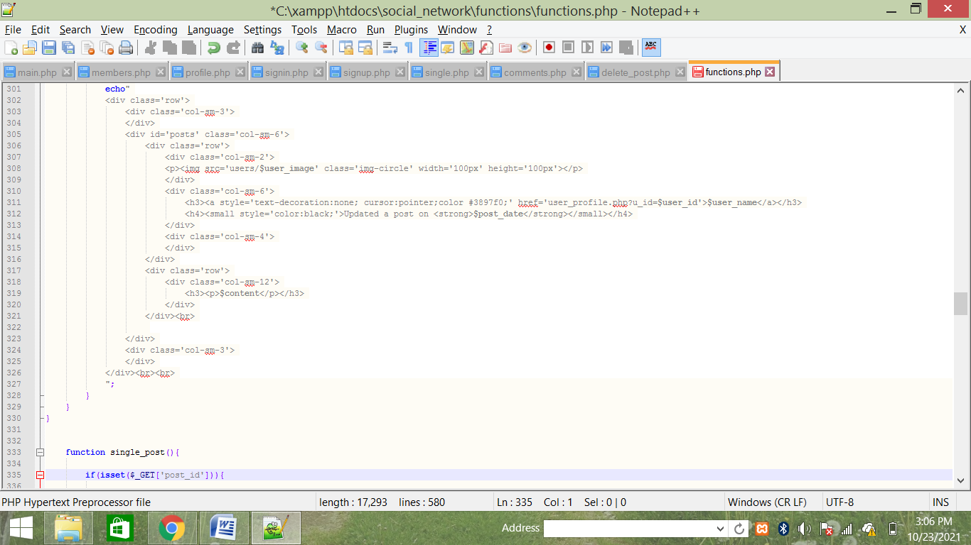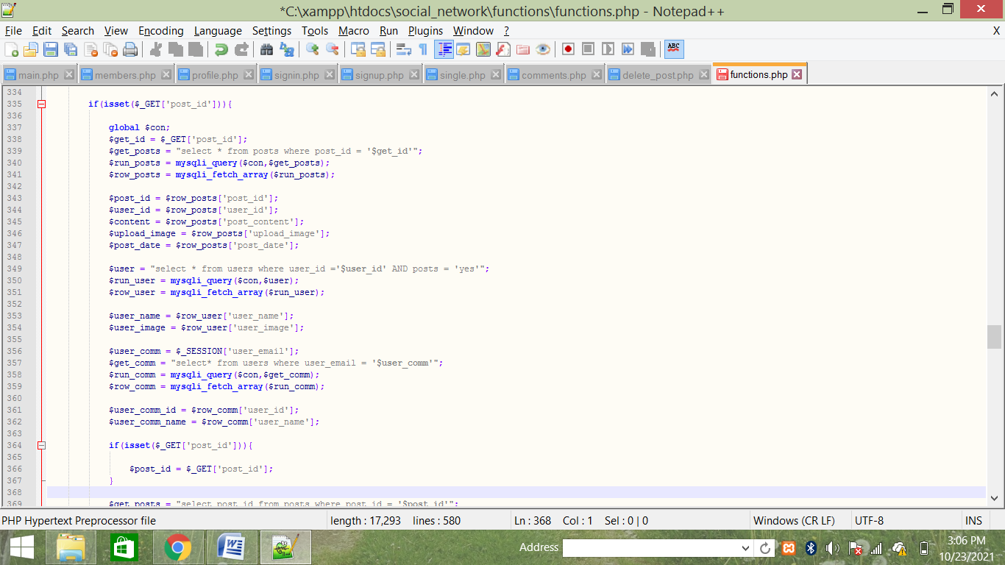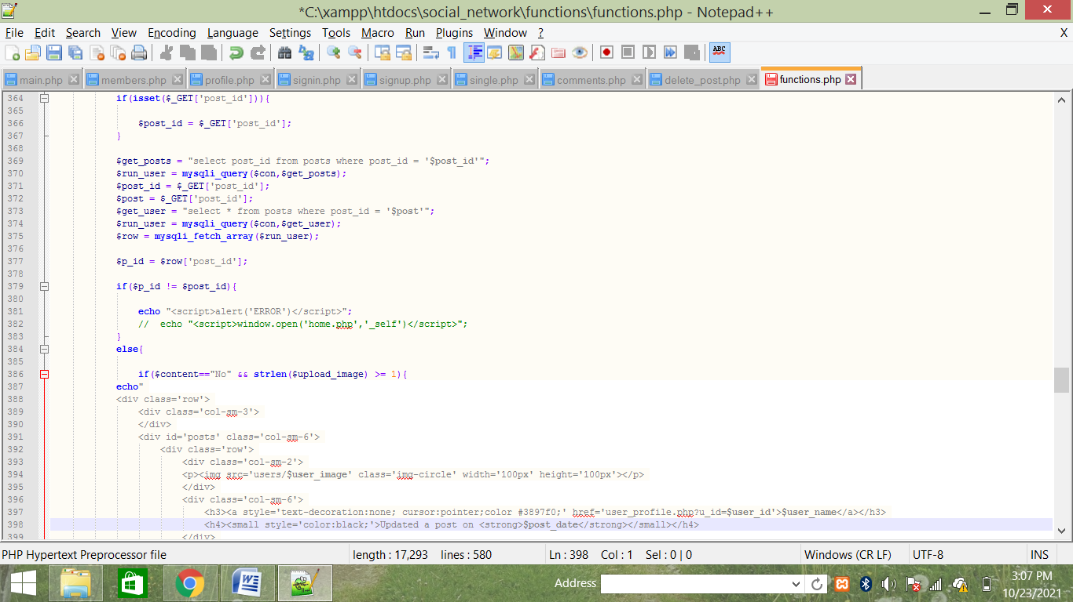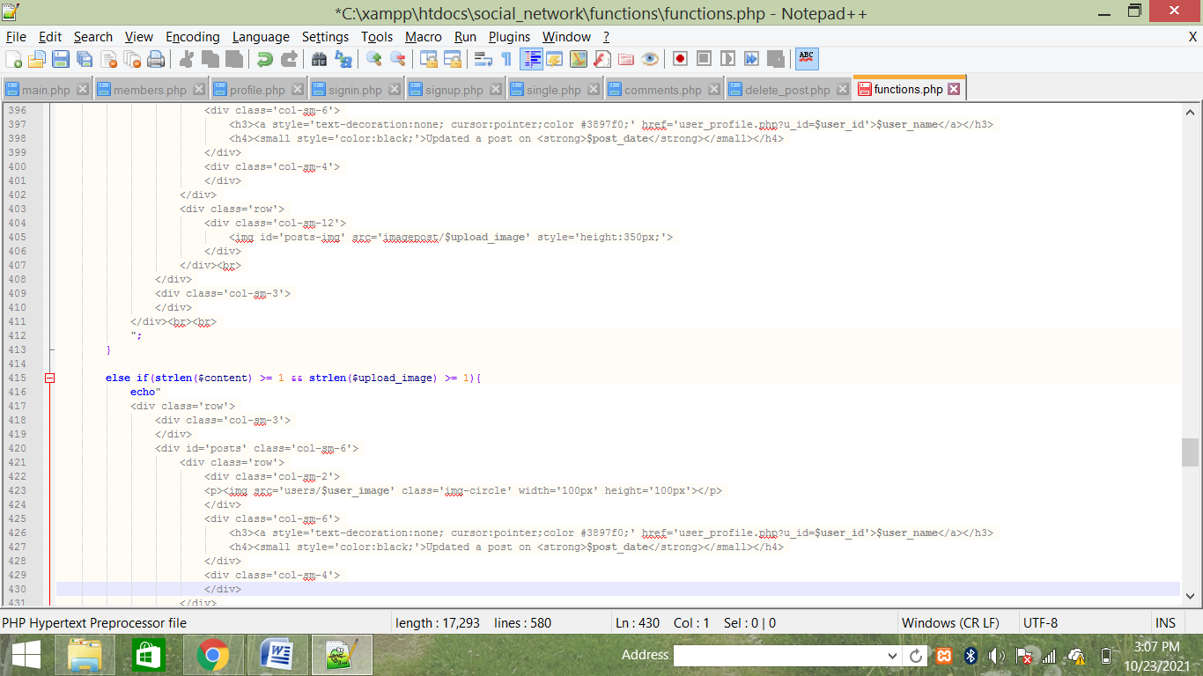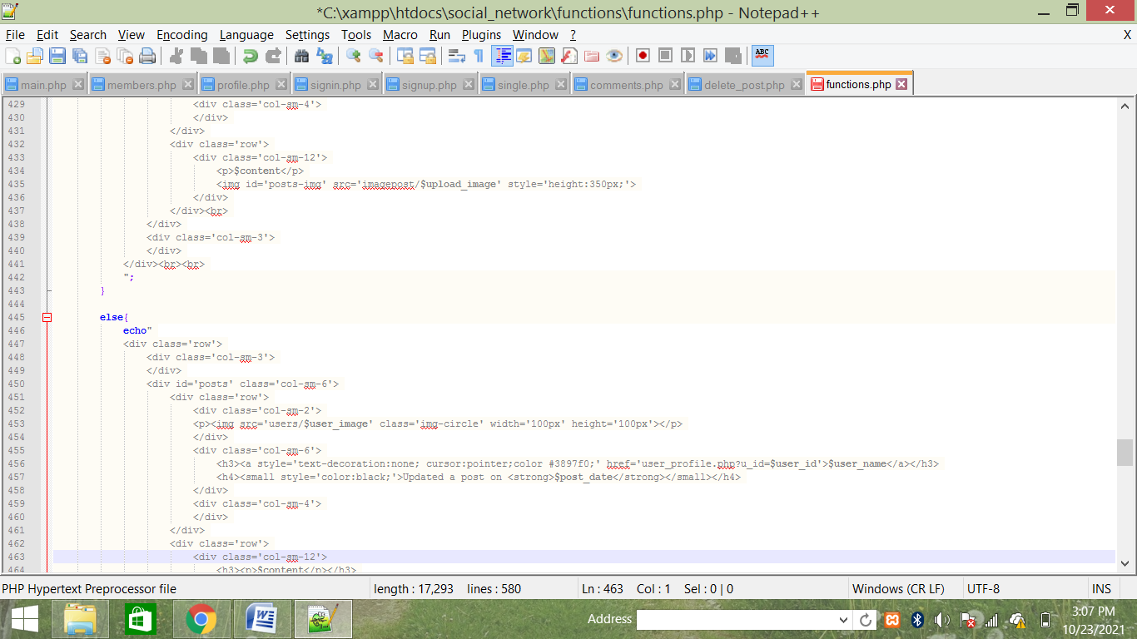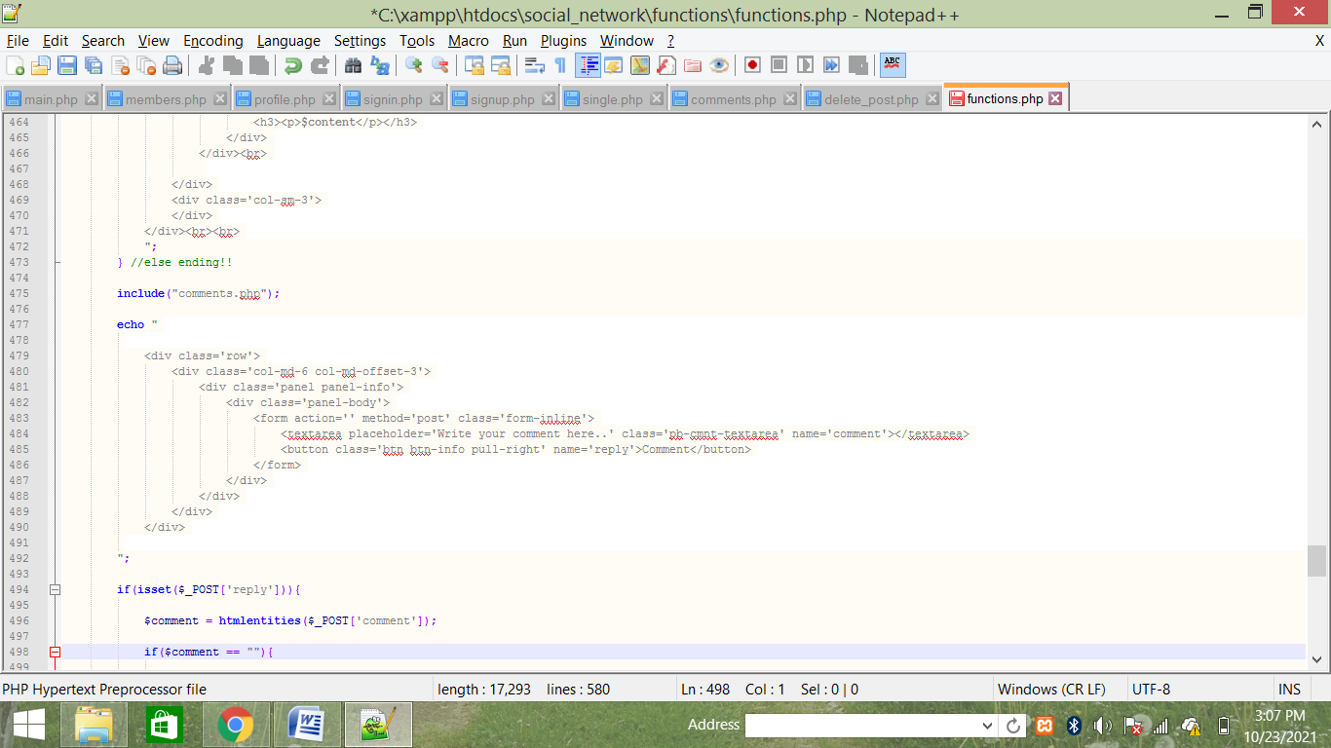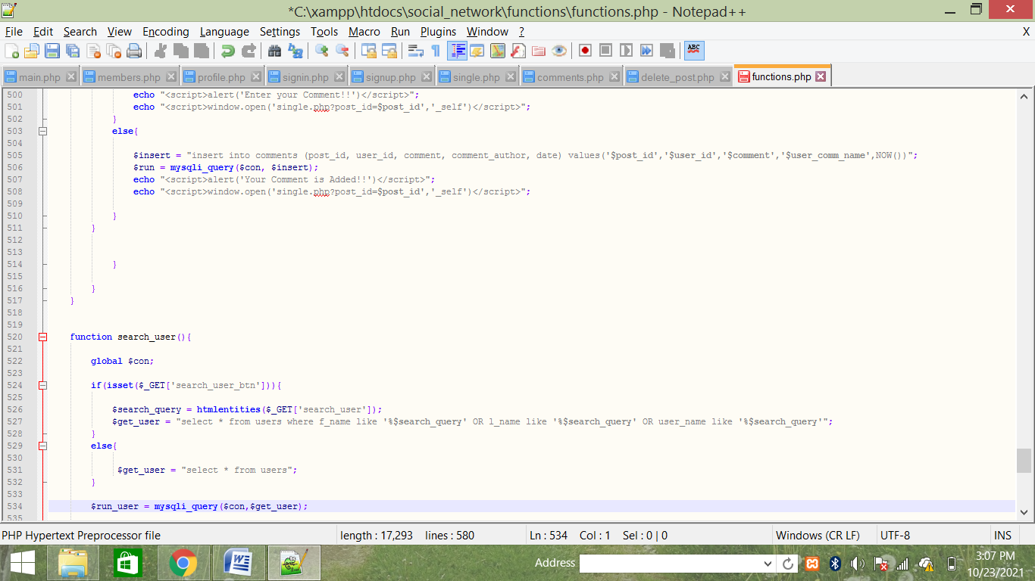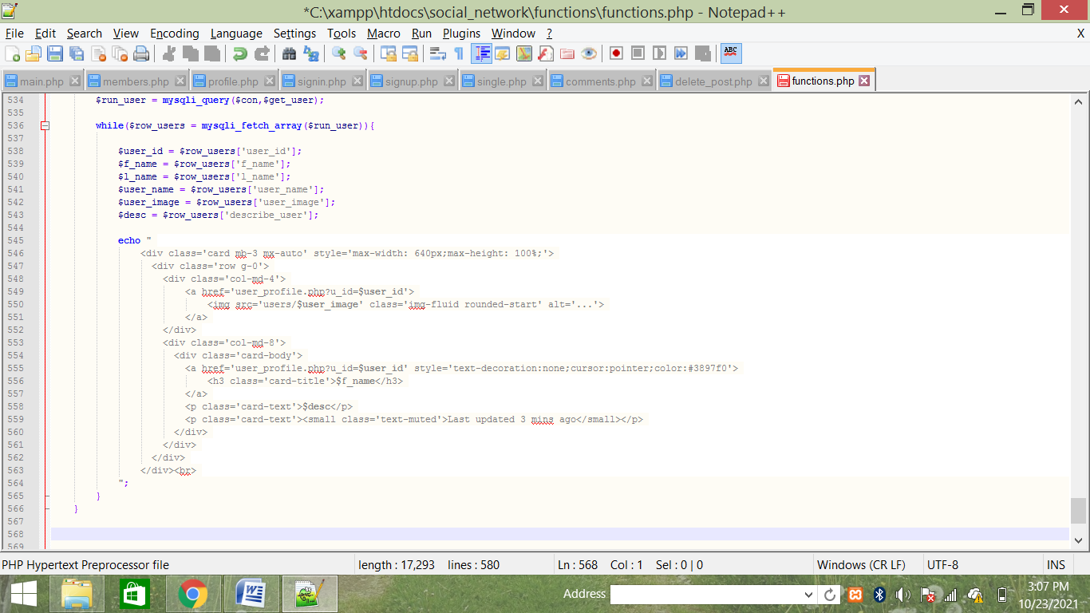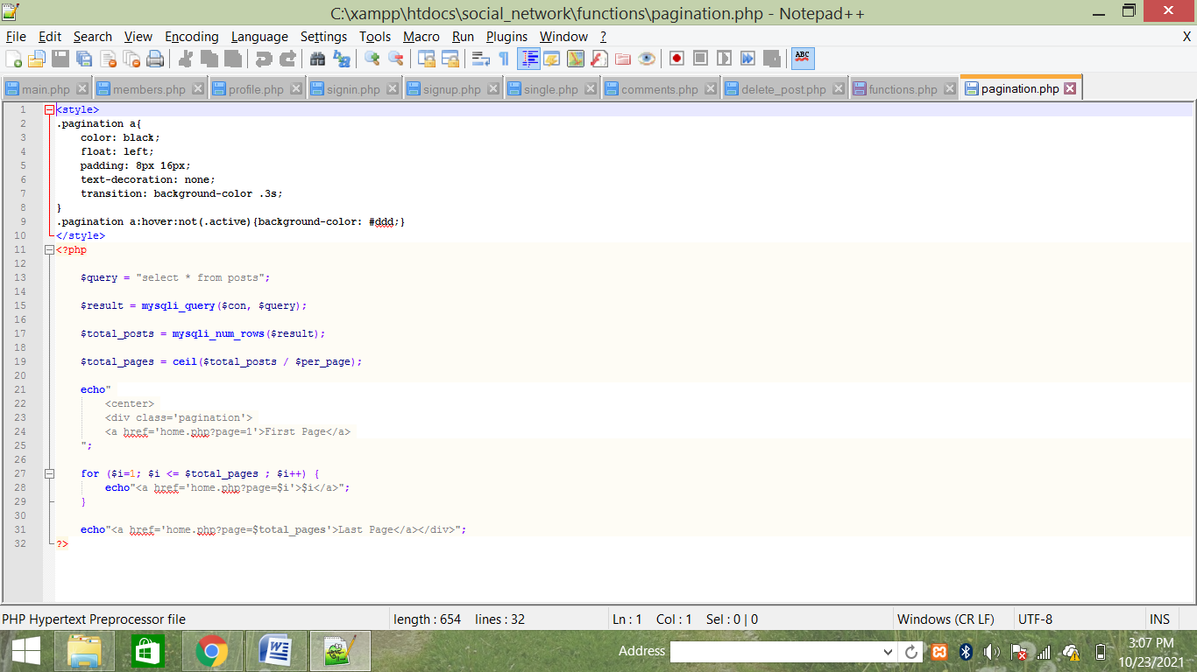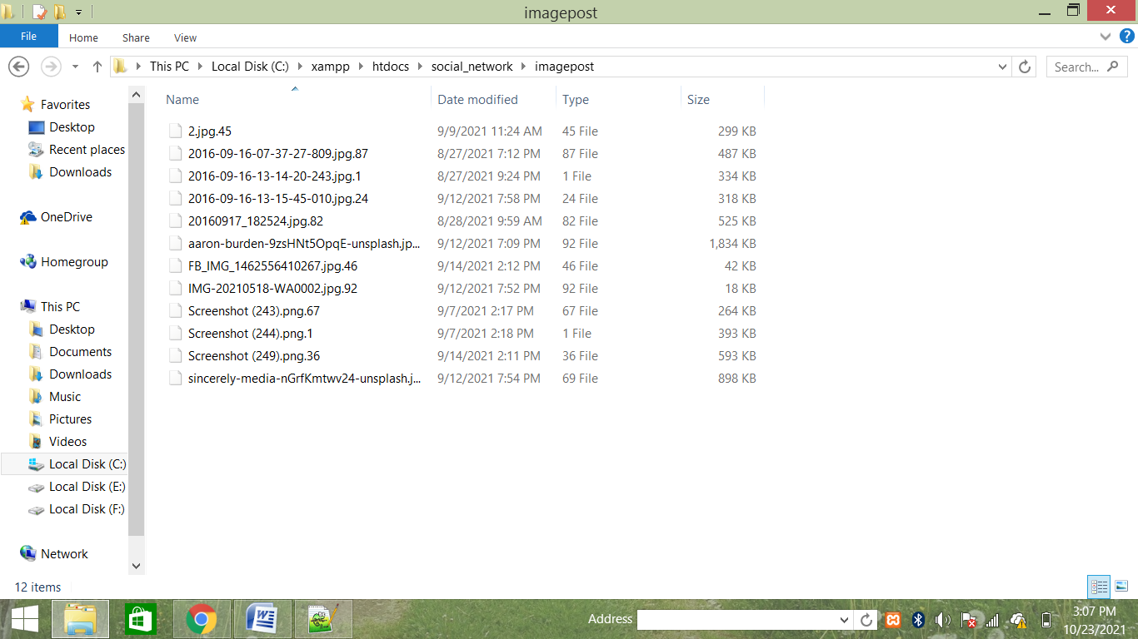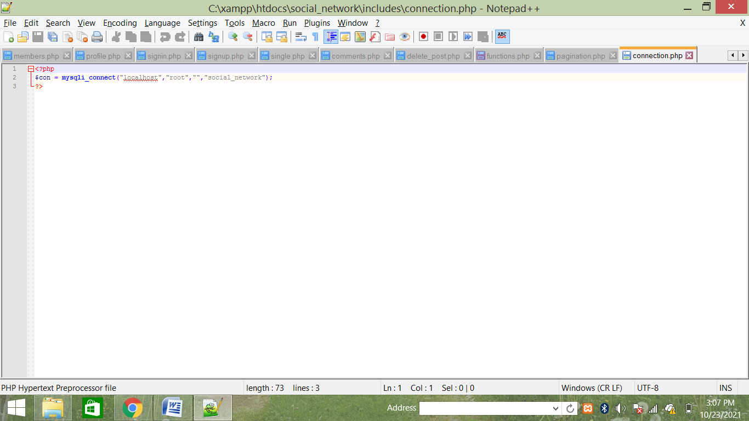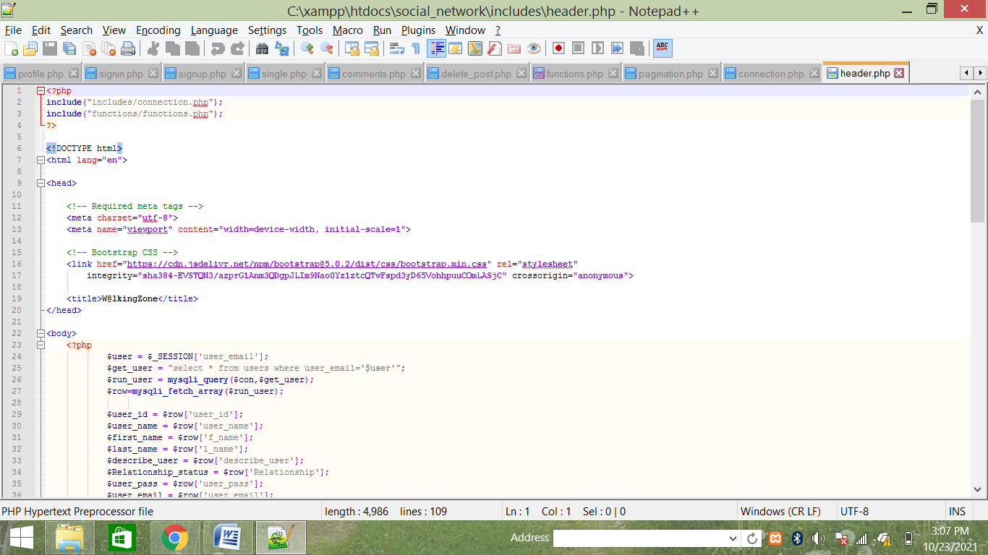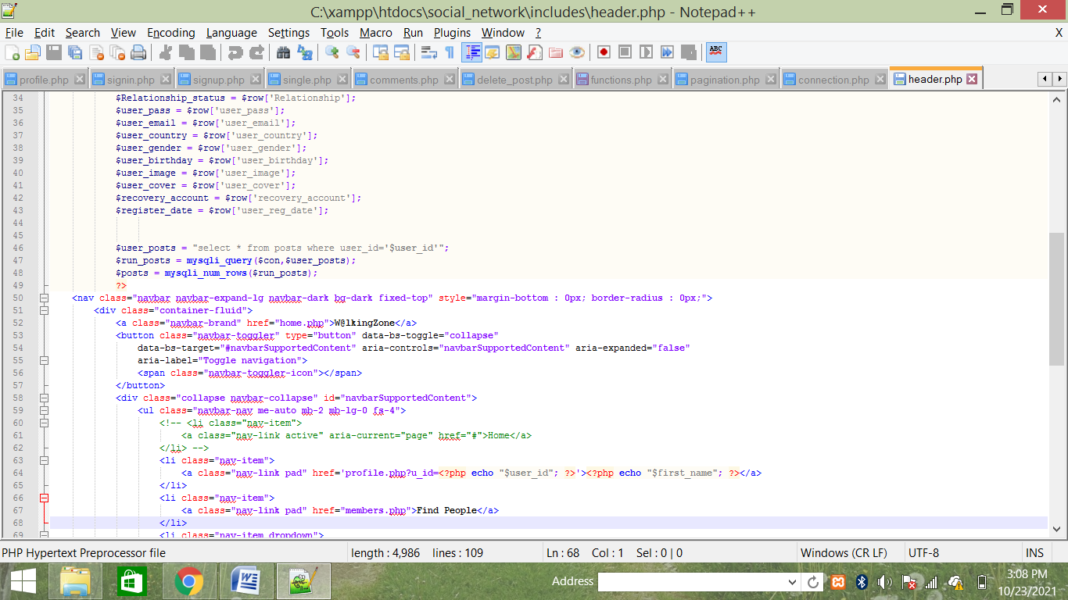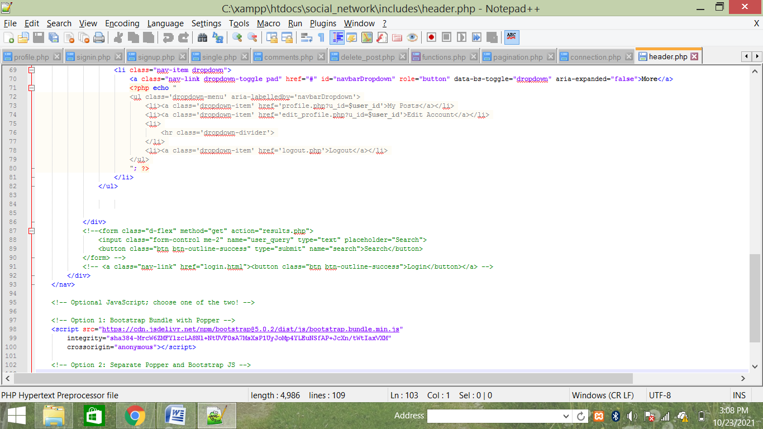**

**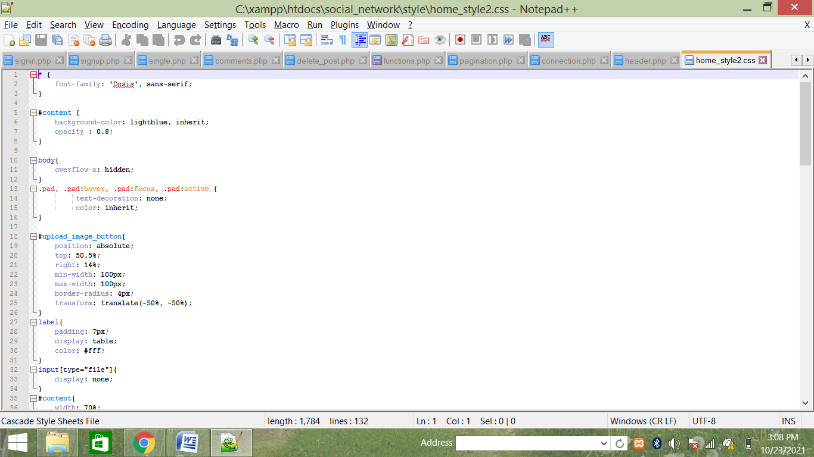**

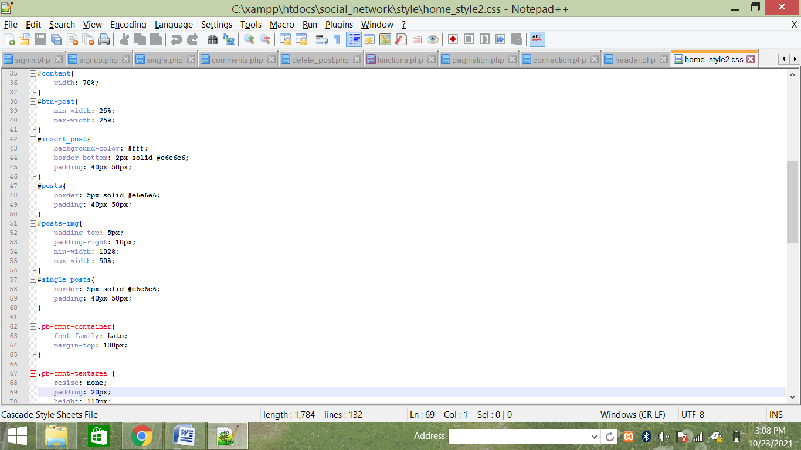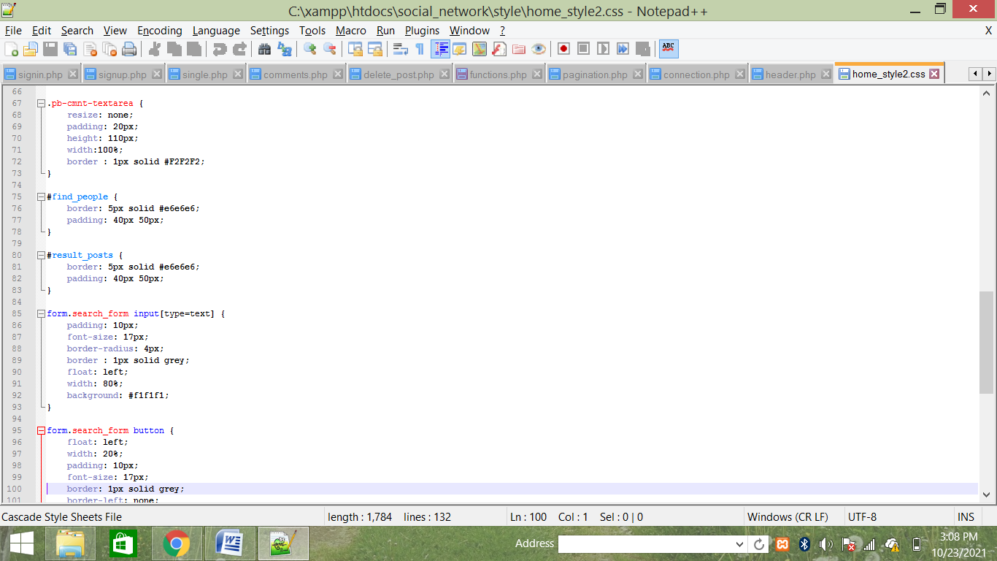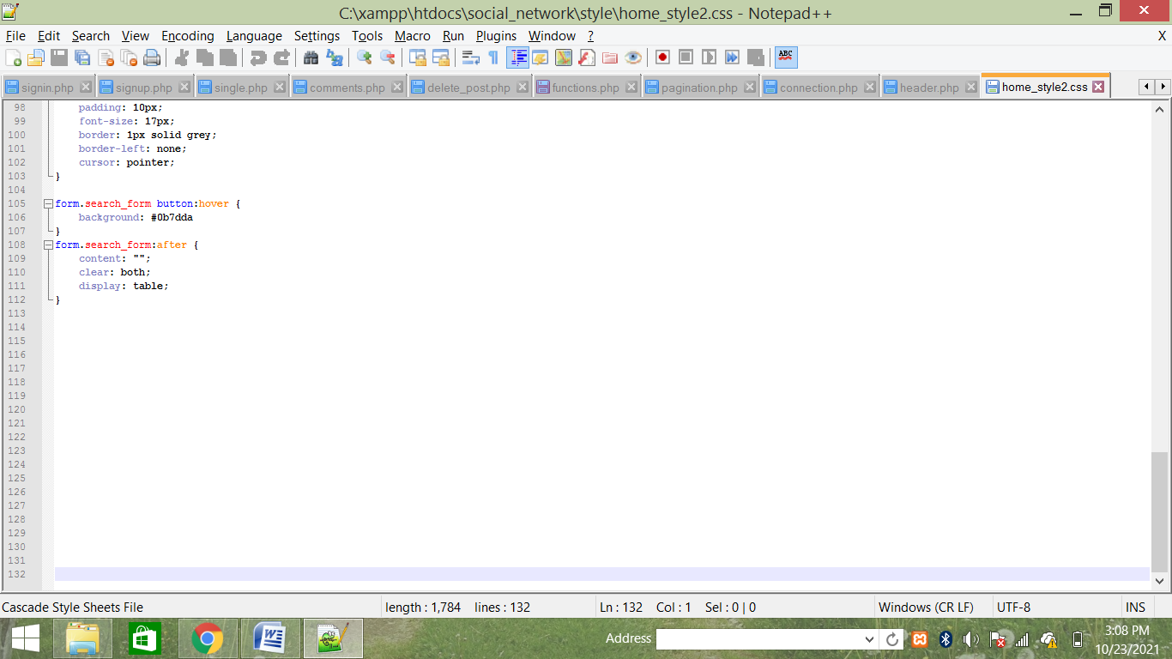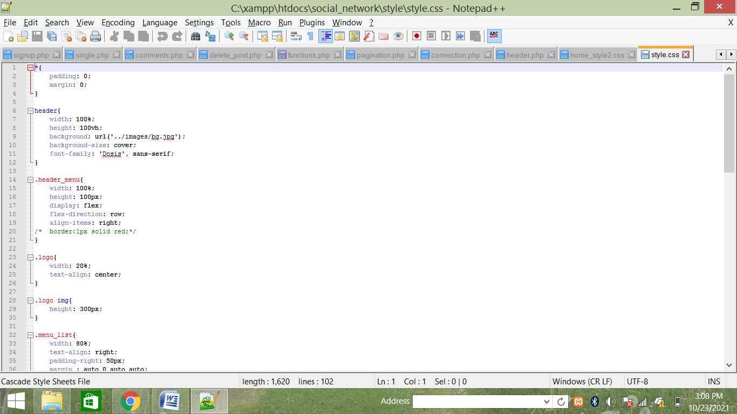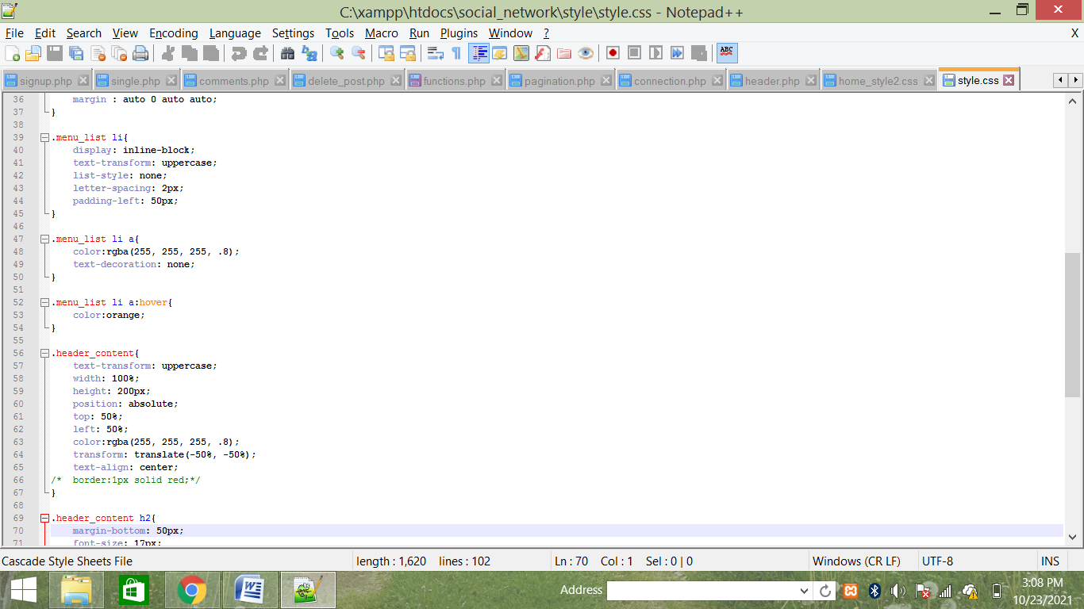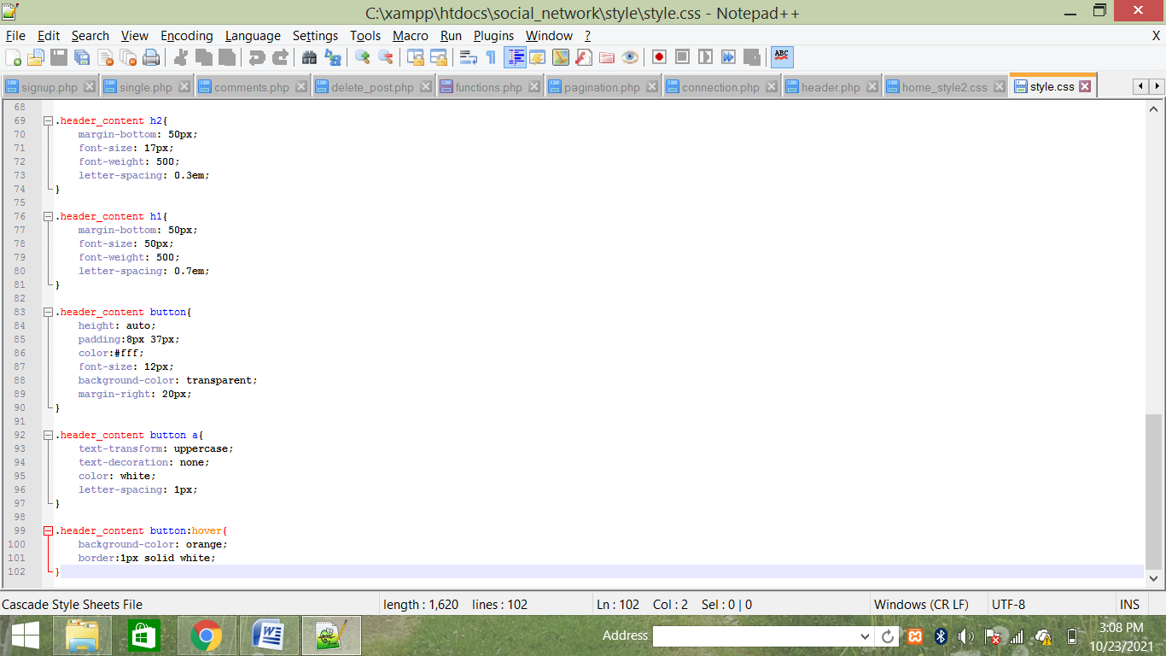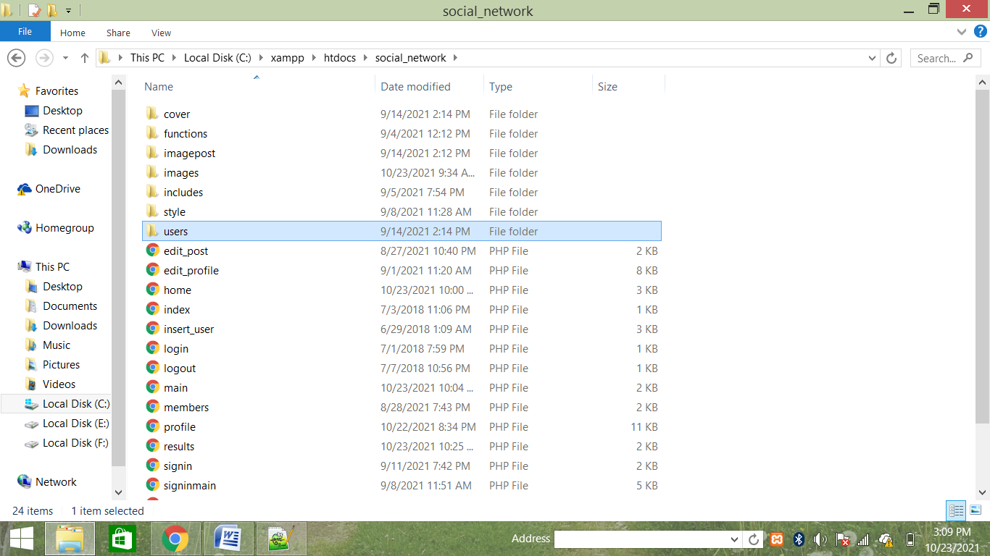

**TESTING PROCEDURES**

The main objective of the testing here is to execute a program and find the errors, so that software can function according to specification specified for behavioral and performance requirement of the software.

1. Testing Techniques:

We have used the following testing technique for finding errors in this software:

(A) White Box Testing Technique:

We have used this method to exercise the internal program logic. During the course of white box testing, I have done the following work.

All independent paths within a module are exercised at least◊ once.

All logical decision on their true and false side is also exercised.

◊ All loops were executed at their boundaries and within their◊ operation bounds. Validity of internal data structure was also exercised.

◊ Some of white box testing techniques, which we have used for this software, are:

1. Basis Path Testing:

2. The basis path methods enable me to derive a logical complexity measure of a procedure design and this measure is used for defining a basis set of execution path. This path ensures to execute every statement in a program at least once.

3. Control structure testing:

Since the basis path testing was not enough, hence the control structure testing is used to exercise the logical condition in a program module. During the course of testing, I have done the following activities, which are described below

After testing all conditions, we have found some errors like:

◊ Boolean variable error in the module cost benefit analysis.

◊ Case:

In cost benefit analysis, we have used the concept of relative cell referencing in this contact; we have taken two types of cell

(i) Variable cell,

(ii) function based constant value cell.

Only user can modify variable cell but function value cell only display manipulated value. If cell is functional cell, its return TURE lese FALSE. During course of testing, we have found this function not return value properly. So we have separately test this function for Boolean errors. Relational operator error.

◊ Boolean Parenthesis error.

◊ Arithmetic expression error.◊

After that we have tested the flow of data across the variable in the◊ module. All the loops are also tested to ensure the validity.

We found that a◊ loop in the cost benefits analysis modules was functioning more than required iteration; it was later corrected to run within the required iteration.

(B). Black Box Testing:

This method is used to test the functional requirements of the software as specified in the section of S.E. Requirement Specification. By using this technique I have found errors in the following categories: o Incorrect or missing functions o Interface errors o Errors in data structure o Behavior or performance errors and o Initialization and termination errors Under the Black Box testing we have used the following types of testing methods:

4. Testing Strategies: Testing strategy, which I have used here to integrate software test case design methods into a series of steps, can be categorized into two spectrums: Code Testing.◊ Specifications testing.◊ The testing strategies, which I have used here, have the following generic characteristics First component level testing are performed and then we moved◊ towards the integration of the entire software. During the course of various types of testing, user involvements are◊ also considered. Different types of testing are performed at different points of time.◊ A. Unit Testing: I have taken following steps during unit testing: I. The module interface is tested to ensure that information properly flows into and out of the program unit under test. II. The local data structure is examined to ensure that data stored temporarily maintains its integrity during all steps in a program execution. III. All independent paths within each module are exercised to ensure that all statements in a module have been exercised at least once. IV. Boundary is tested to ensure that the module operate properly at boundaries established to limit or restrict processing. V. Finally all error handling path are tested.

Case: During the code implementation, we have face with precision problem In “cost benefit analysis”.

B. Integration Testing:

During this phase we have combine all the module and perform integration sting for constructing the program structure while at the same time conducting tests to uncover errors associated with interfacing. In order to integrate all the modules we have used Bottom up approach. C. Validation Testing: After the completion of integration testing and removal of interfacing problem, we have conducted validation testing according to reasonable expectation of user specified in the S.E.Requirement specification documents. Since this s/w is designed for management, hence a series of acceptance tests are also conducted. The acceptance test is conducted is conducted by Mr. Neeraj Kant Jha and he is found the satisfactory performance of the software according to their needs. D. System Testing: Finally we have conducted the system testing to fully exercise the currently developed computer based system “Medicine Distributor Management system”. Following tests are performed during this phase: I. Recovery Testing: During recovery testing we have exercised fault tolerance capacity of system, ability to recover from failure. We found that the system is fault tolerant and processing fault is not causing overall system function to cease. II. Security Testing: We have made various attempts to penetrate the data stored in the system.

**CONCLUSION**

While writing solution to this problem, I realized that right attitude towards problem solving with at least an average aptitude gives dynamic result. At start, I was having no roadmap, but subsequently as I progressed all become clearer and clearer, finally I am writing the Termination Analysis. All the process that I have used can be used informally, but it’s formal execution I have found almost necessary to give it a professional touch, which after realizes into its commercial value. I have also realized that, if any project doesn’t have commercial nature, its completion or incompletion doesn’t have any meaning. Additionally talking to seniors and experts, proper documentation and investigating attitude are must to develop a project

**BIBILOGRAPHY**

I Mayank kumar Prasad student of giit professional college studying Bsc.it have done this project with the help of my Teacher, friends and family also.

**I used websites such as:-**

•Vs code.

•Xampp server

•Geeksforgeeks.com

•Tutorialspoint.com

•Javatpoint.com

•Stackoverflow.com

•W3school.com

•Github

•Youtube.com etc.

**I Also used some Youtube Channel such As:-**

•CodeWithHarry

•ThapaTechnical

•Programmig with Mayank. Etc.